Ijarah Transfer of Ownership
UT Document

Document History
Author | Version | Date | Description
Taha Faruqi  Muhammad Ali | V1.0 | 9th Apr 2026 | Initial Document
Taha Faruqi | V1.1 | 9th Apr 2026 | Final Document

Table of Contents
Summary 5
Old Arrangement Details 6
Old Arrangement Early Payoff Amount 6
Early Payoff Simulation of Old Arrangement 6
New Restructured Arrangement Creation 8
New Application Details 8
New Application Creation 8
Application Submission 8
Application Status After Submission 9
Request Overview Details on Assist 9
Transact Simulation 10
Offer Acceptance 10
Offer and AML acceptance Status 11
SMB DEAL DETAILS 11
Financial Details 13
Financial Details of Application Part 1 13
Financial Details of application Part 2 14
Servicing Module Section 14
STP Status Enquiry – Bill Generation 15
Bill Generation 15
Generated Bill 15
Rosom 16
Bill Status - Received 16
STP status enquiry - Bill Payment Confirmation 17
Credit Admin Stage 17
PO and Vendor Details of Application 18
Financial Information of Application 19
Purchase Order 19
PO Generation 19
Successful Correspondence 20
Updated PO 21
Contract Status 21
Contract Acceptance 22
STP Status enquiry 23
Asset Capture Amend 23
Authorization of Asset Capture Amend 24
STP Status Enquiry – Complete 25
STP Accounting Entries 25
Restructured Arrangement Creation 26
Authorization of Restructured Arrangement 29
Arrangement 360 View 30
List of Transaction Entries 30
Multi-supplier Account 31
Fund Transfer 31
FT Creation 31
FT Authorization 31
FT Credited in Previous Loan Repayment Account 32
Payoff 33
Previous Loan Payoff 33
Payoff Authorization 34
Arrangement after Payoff 35
Schedule 35
Transaction Entry After Payoff 35

Summary
The Loan Transfer Facility enables the transfer of an existing Ijarah loan to a new customer, subject to settlement of all outstanding amounts. A new loan is created, a new CIF and repayment account are created, with Registration & Green card details remain same as of old loan arrangement.
Once the new loan arrangement is booked old loan contract will be adjusted through FT and the old loan arrangement will be subsequently settled and closed. Hence the new loan is named under new customer’s ownership.

Old Arrangement Details
Old App ID: YBSKXXQ
Contract Amount: 15,000
Tenor: 24 Months

Old Arrangement Early Payoff Amount
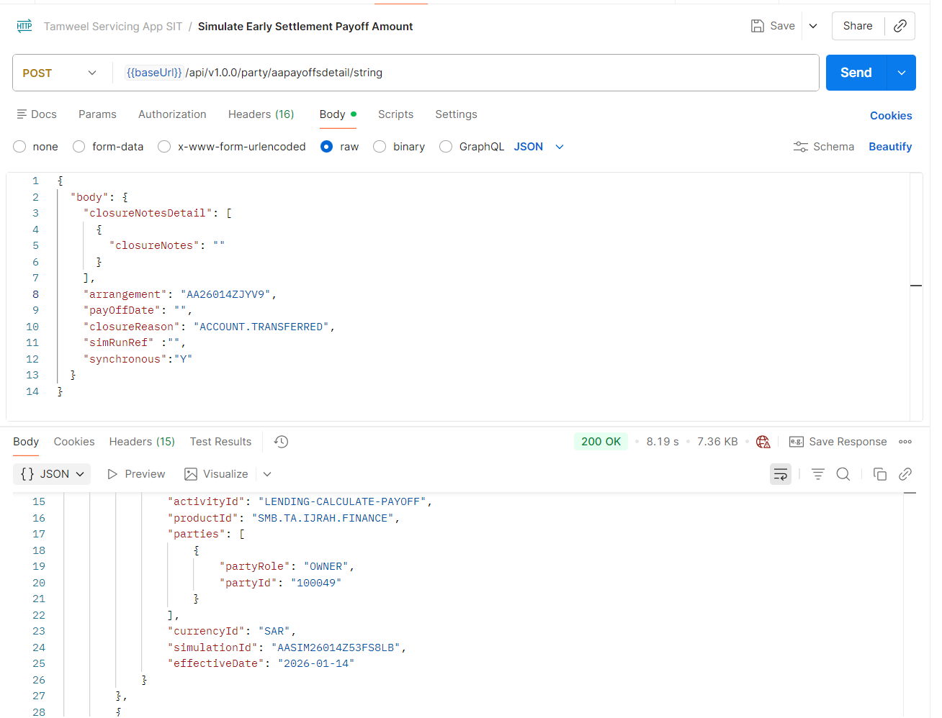

Early Payoff Simulation of Old Arrangement
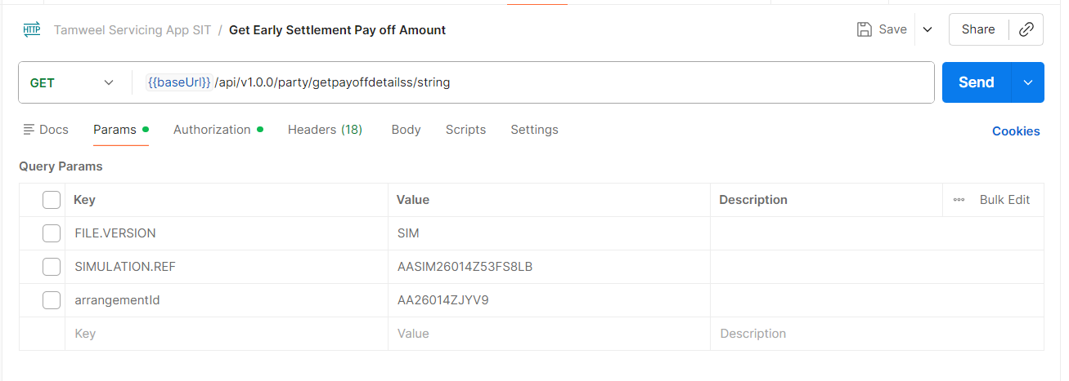
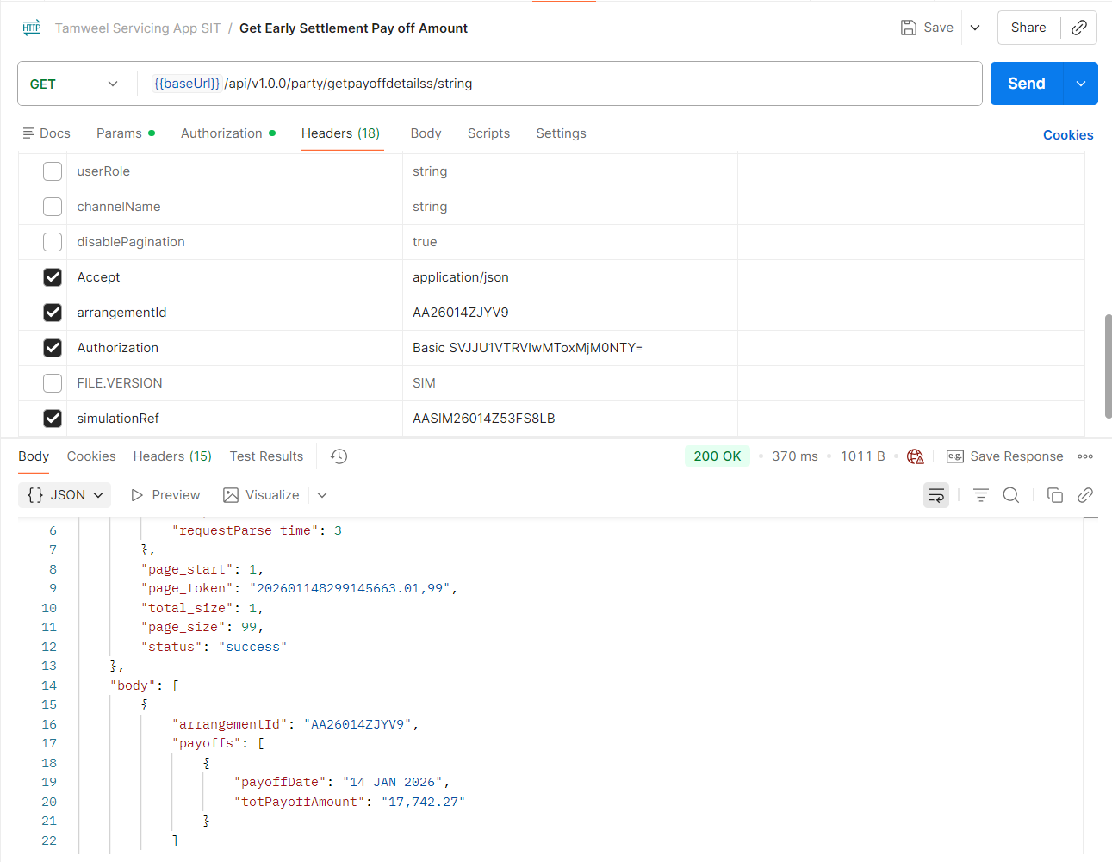

New Restructured Arrangement Creation

New Application Details
Application ID: WNLHFPR
Contract amount: 17,742.27
Contract Tenor: 24 Months

New Application Creation
Application creation through Create Application API.
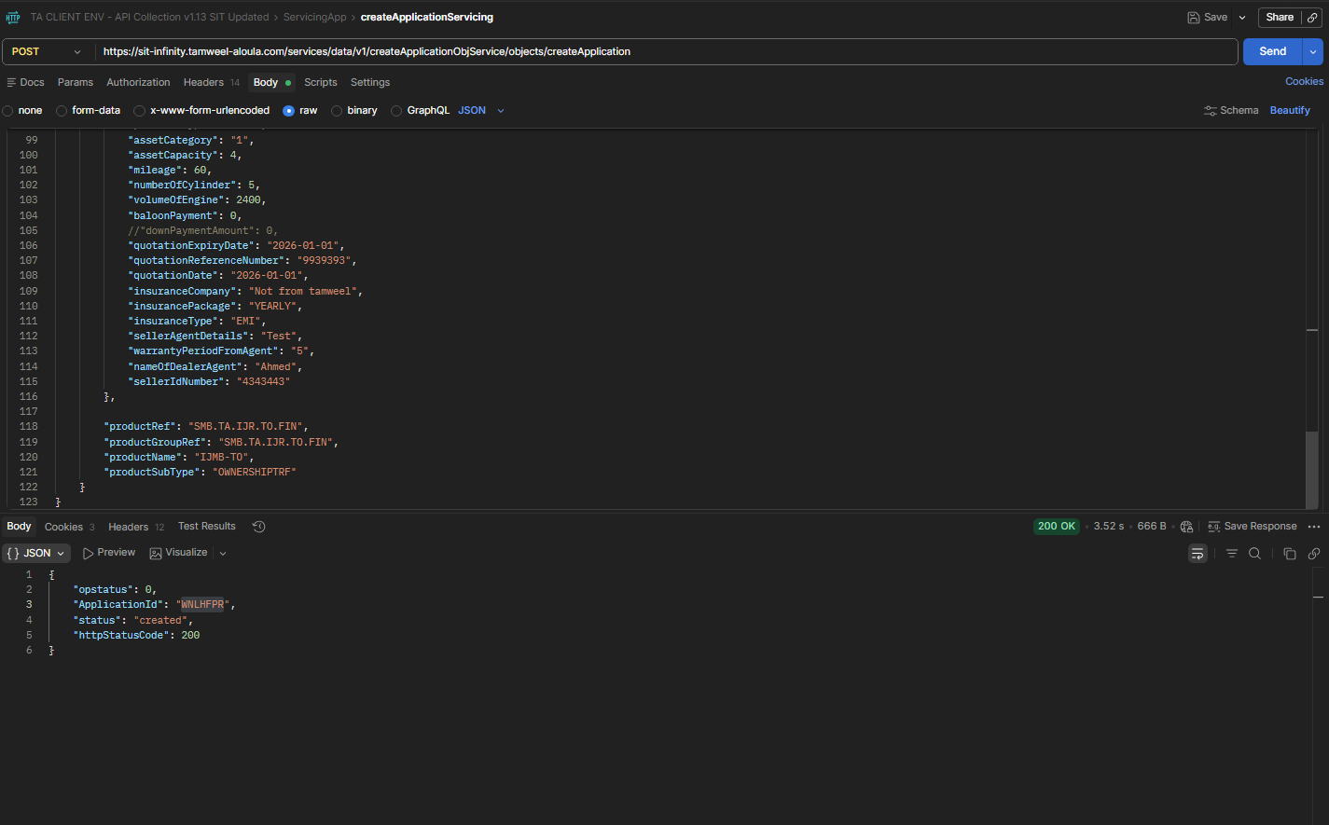

Application Submission
Application submission through SubmitAPI.
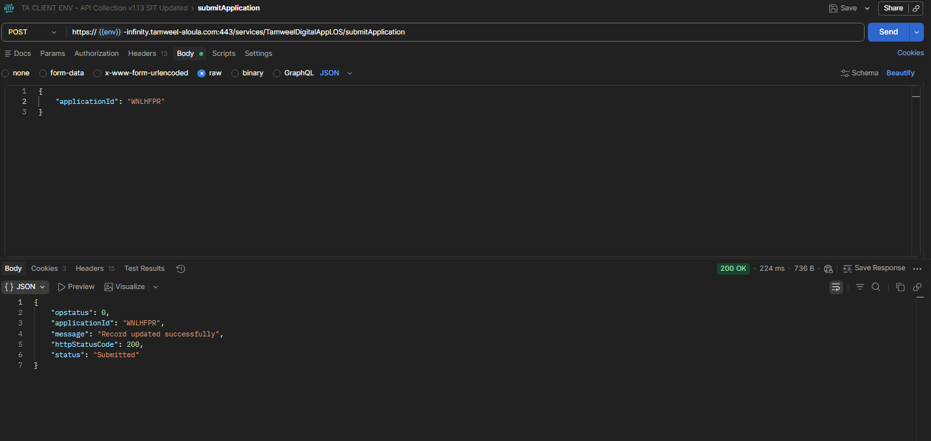

Application Status After Submission
Submitted stage is marked as completed. As response received from Qarar is Accepted and Applied loan amount is less than 75,000, STP flow is initiated because of which offer is generated.
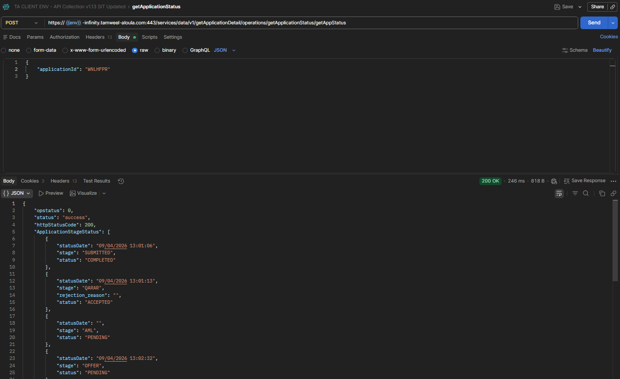

Request Overview Details on Assist
Request Overview details in which Simulation ID alongside with Scheme is reflected.
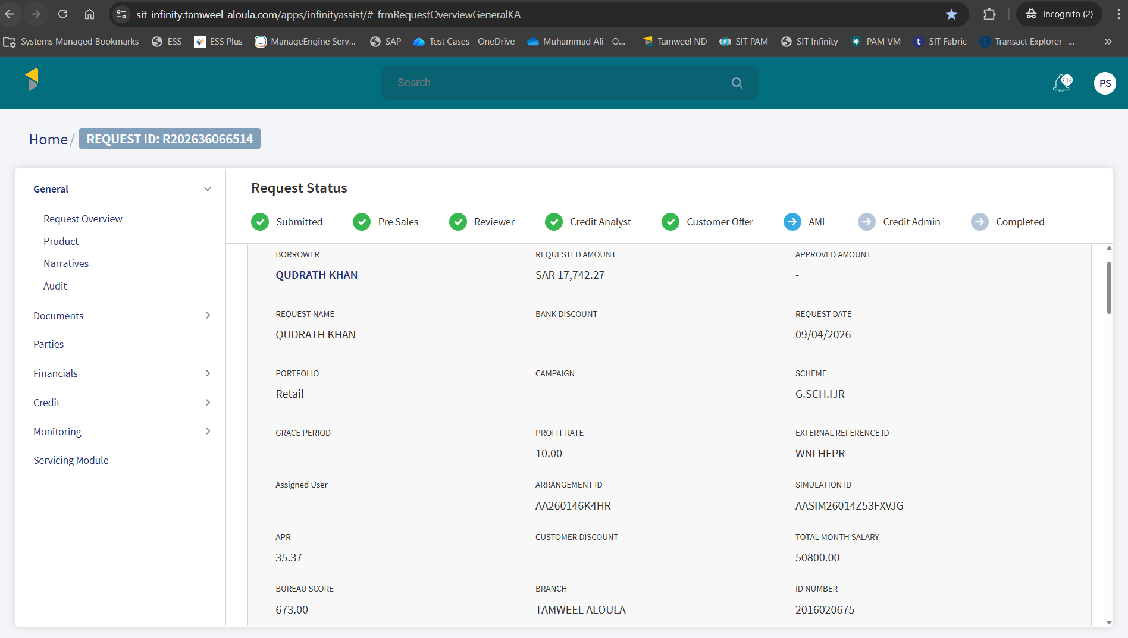

Transact Simulation
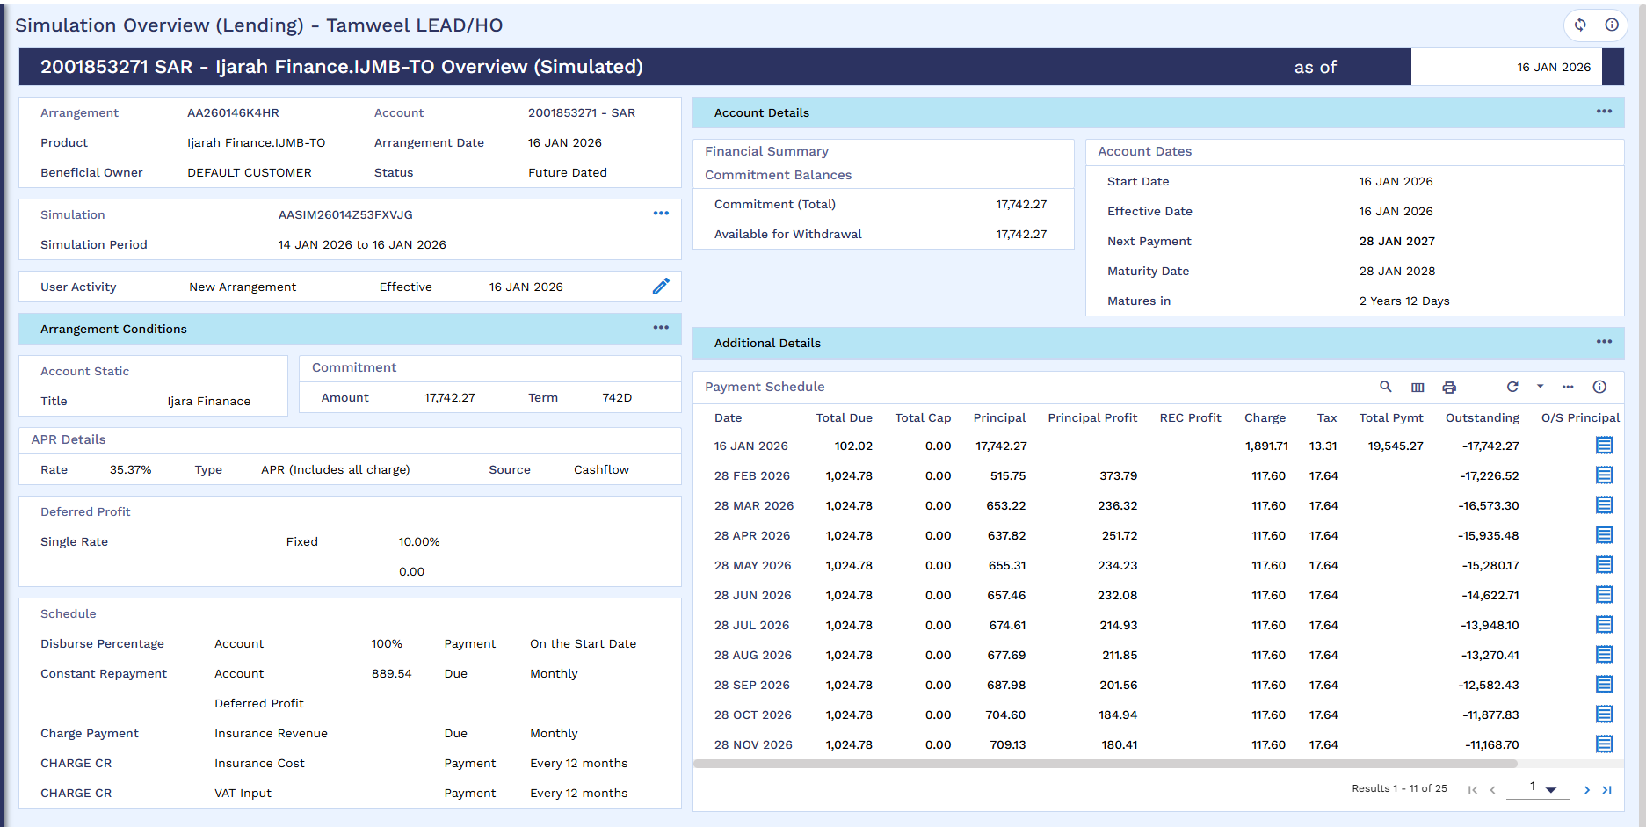

Offer Acceptance
Offer is accepted through UpdateStageStatus API.
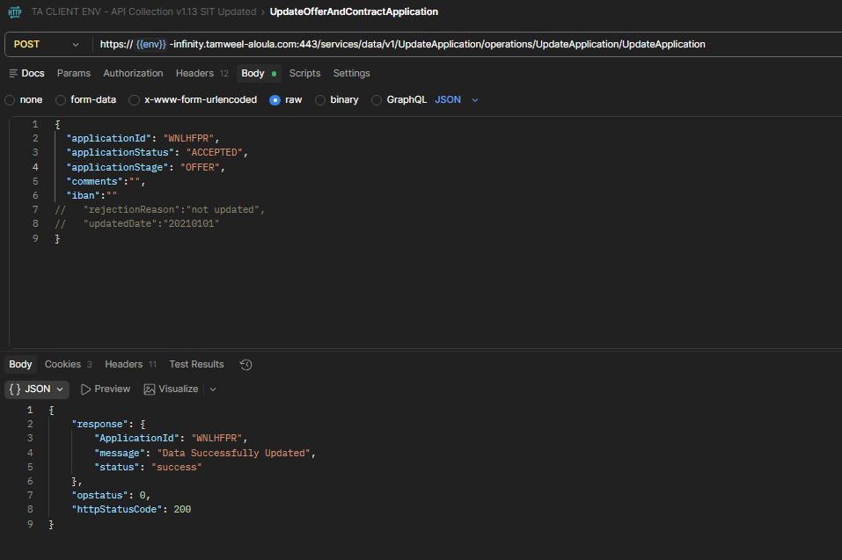

Offer and AML acceptance Status
Offer and AML status is updated to Accepted.
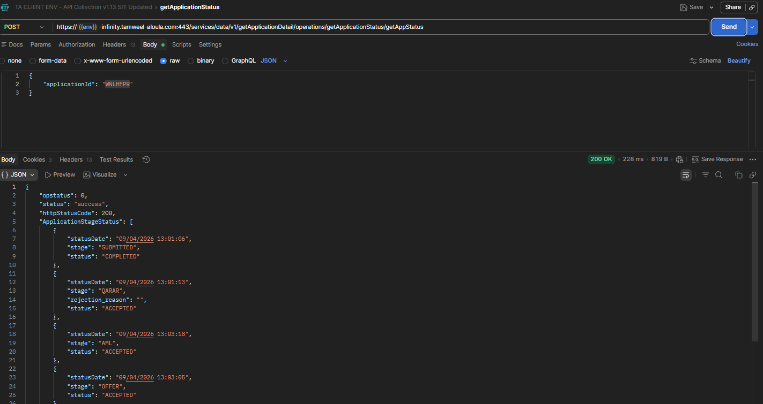

SMB DEAL DETAILS
Vehicle details same as old arrangement.
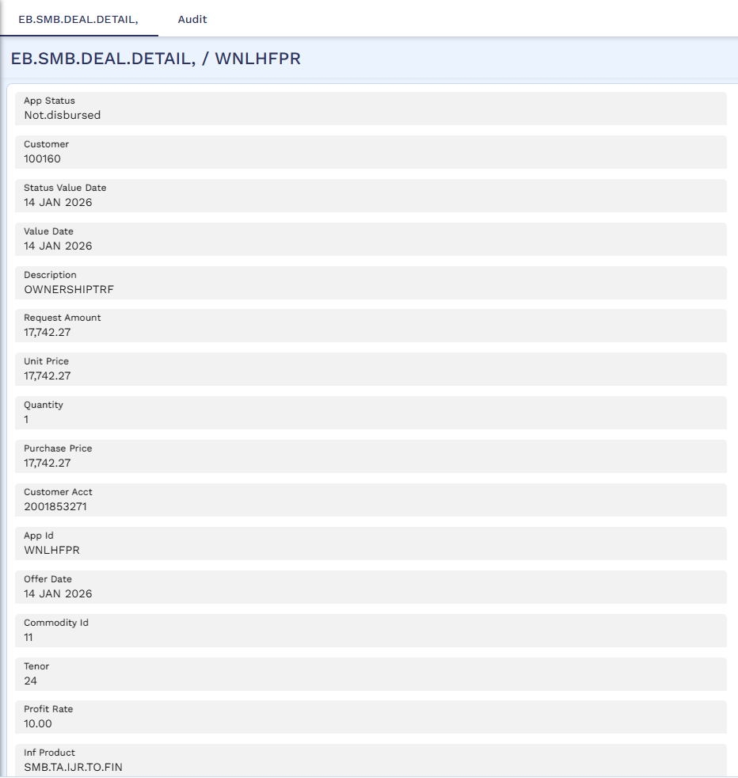
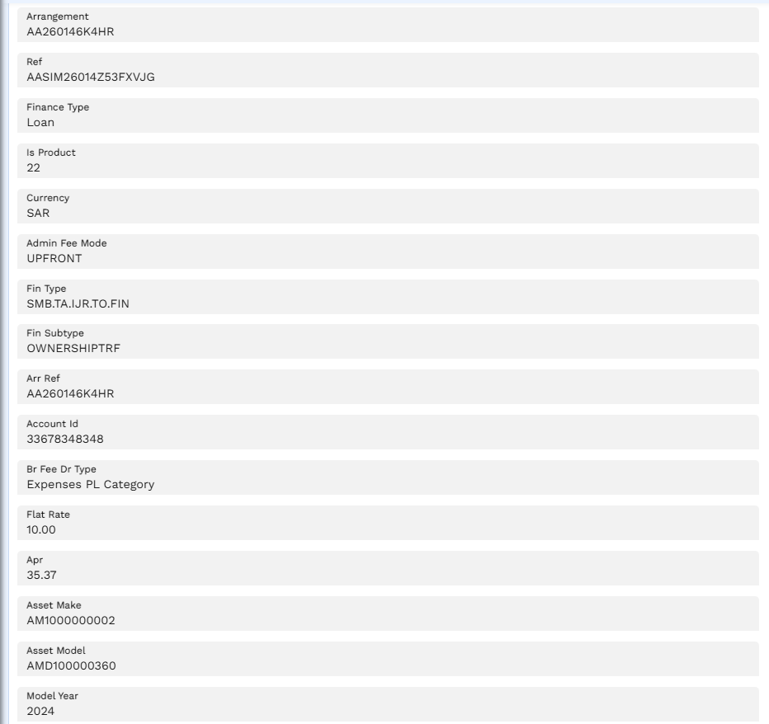
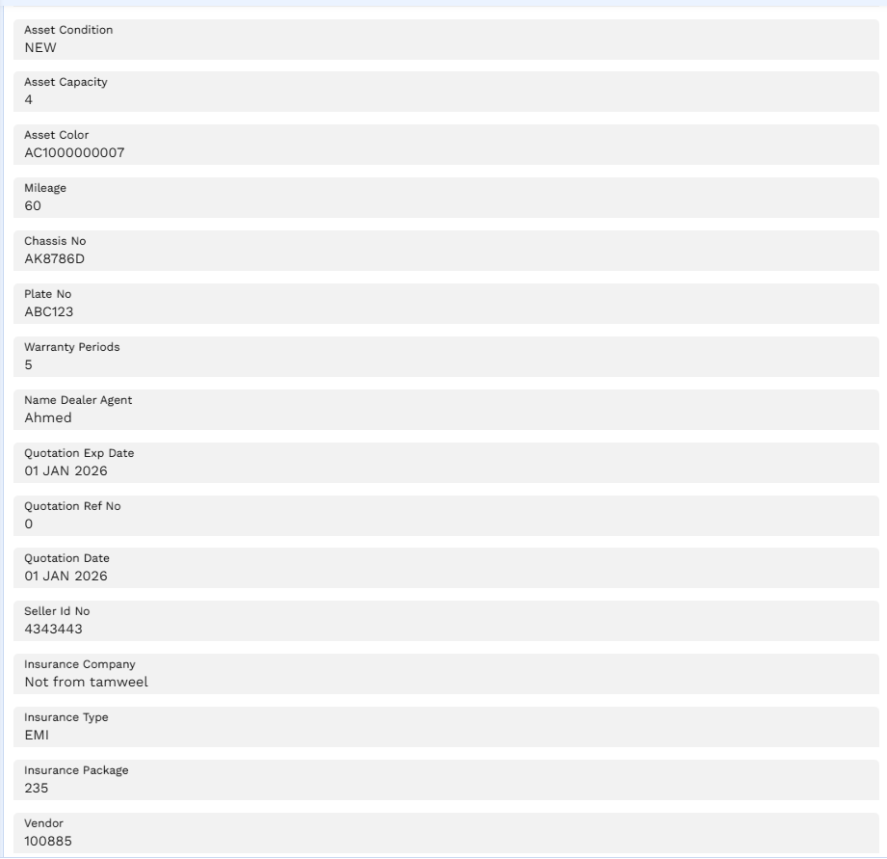
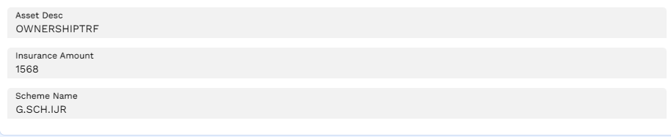

Financial Details

Financial Details of Application Part 1
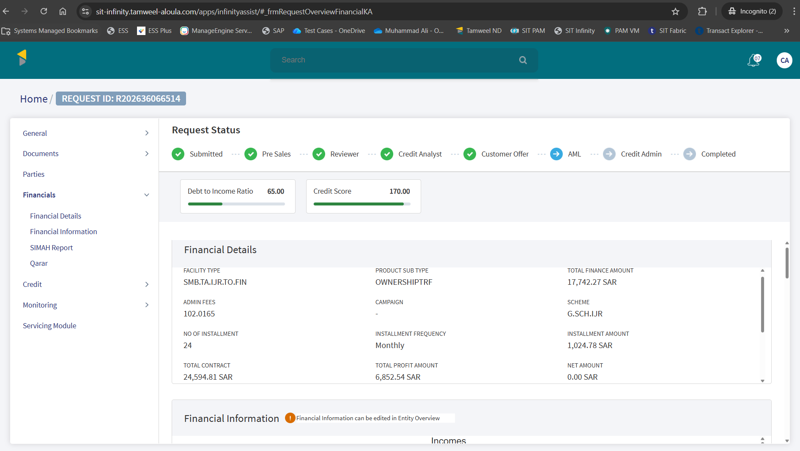

Financial Details of application Part 2
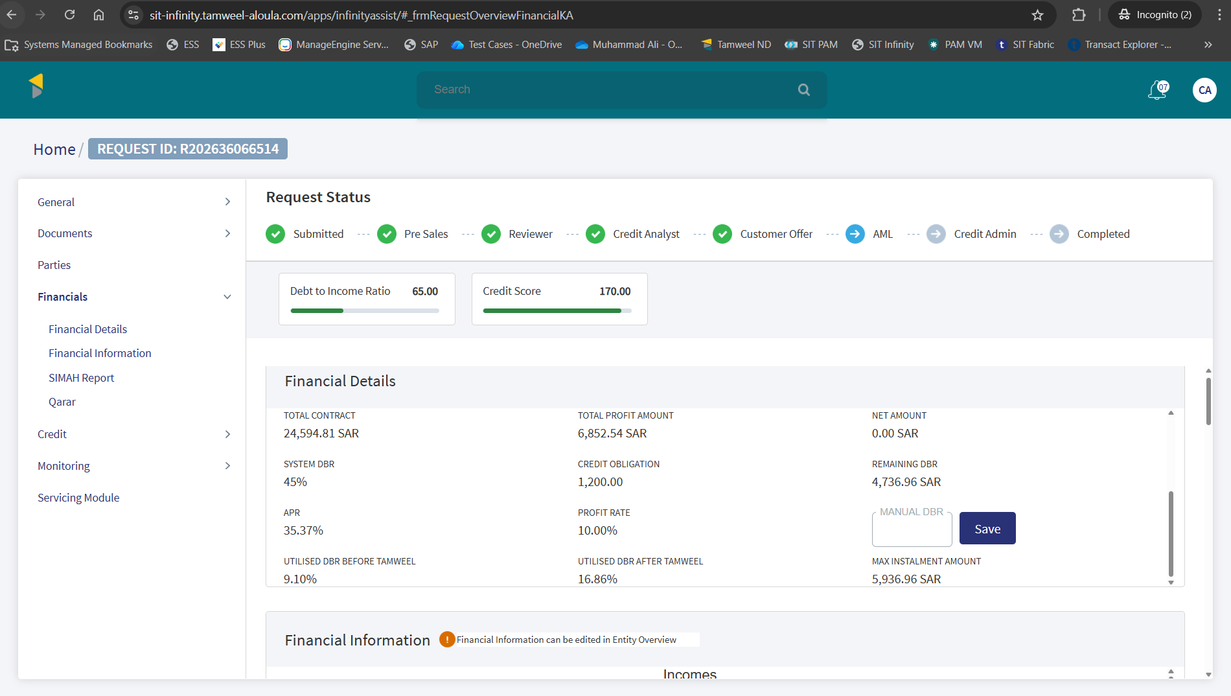

Servicing Module Section
Servicing module section reflecting existing application details.
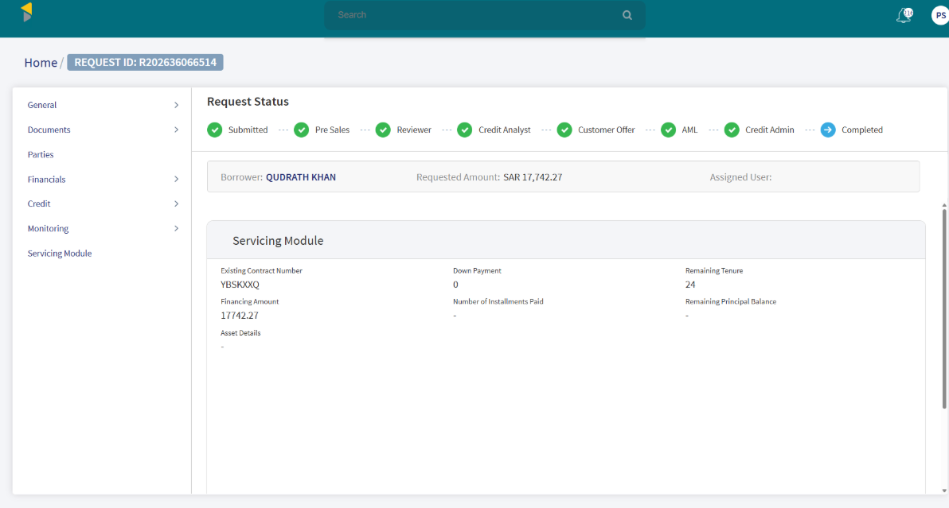

STP Status Enquiry – Bill Generation
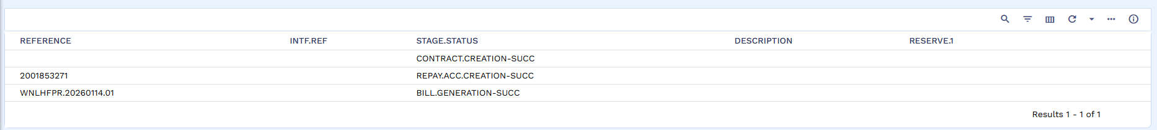

Bill Generation
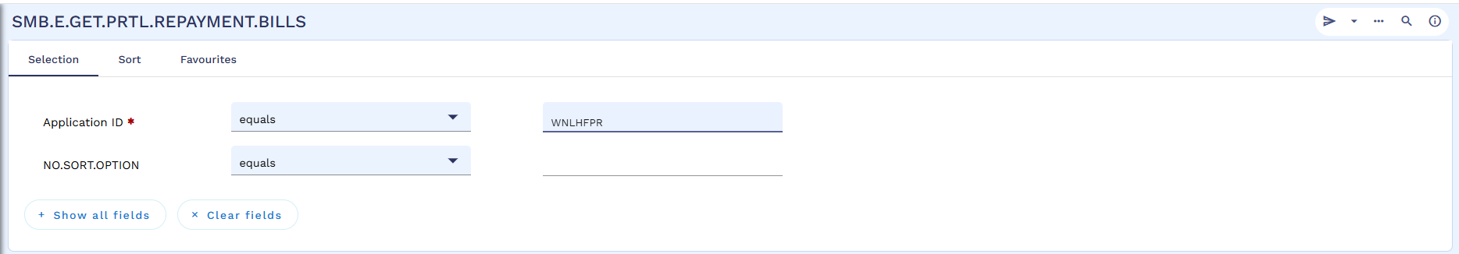

Generated Bill
Below screenshot shows status as uploaded.
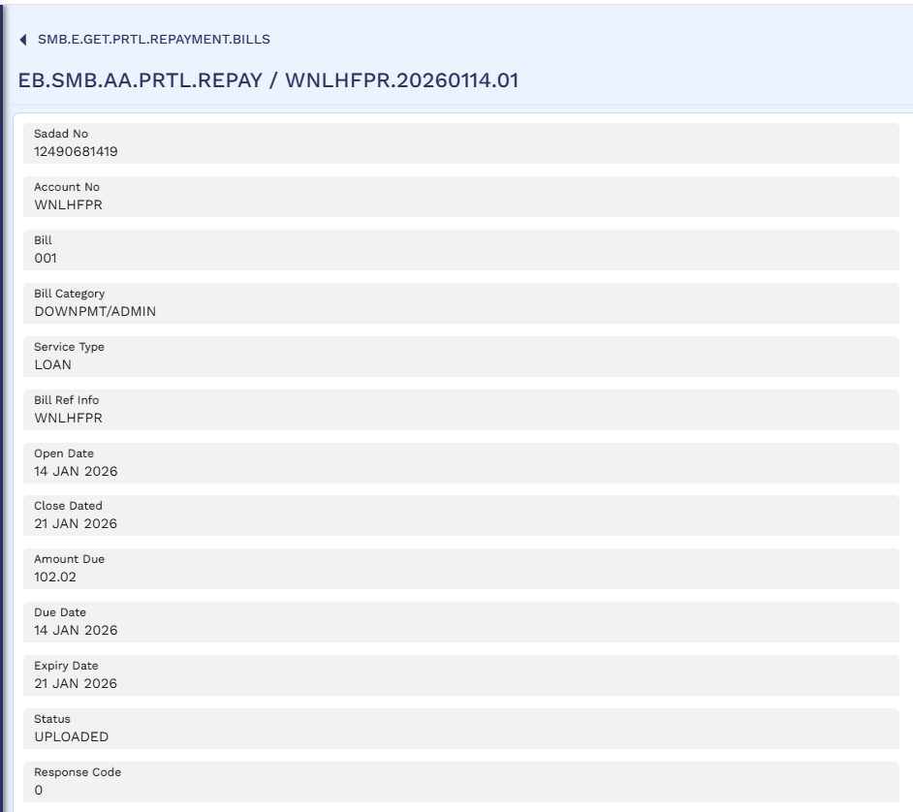

Rosom
Rosom bill generated for Admin Fee plus VAT amount, there will be no down payment in case of loan transfer. 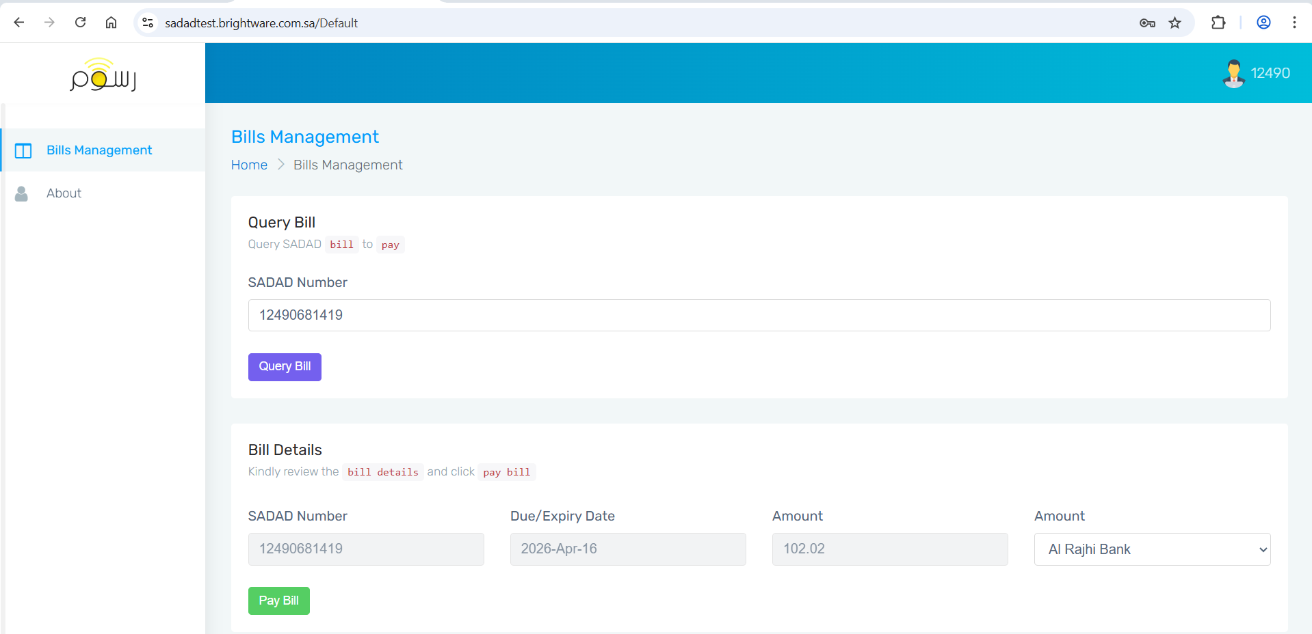
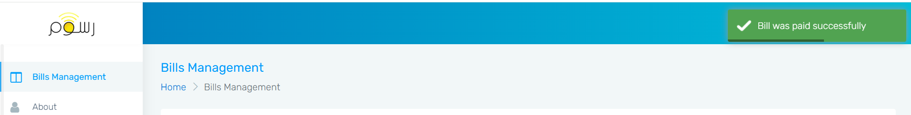

Bill Status - Received
After bill is paid, the status changes to Received.
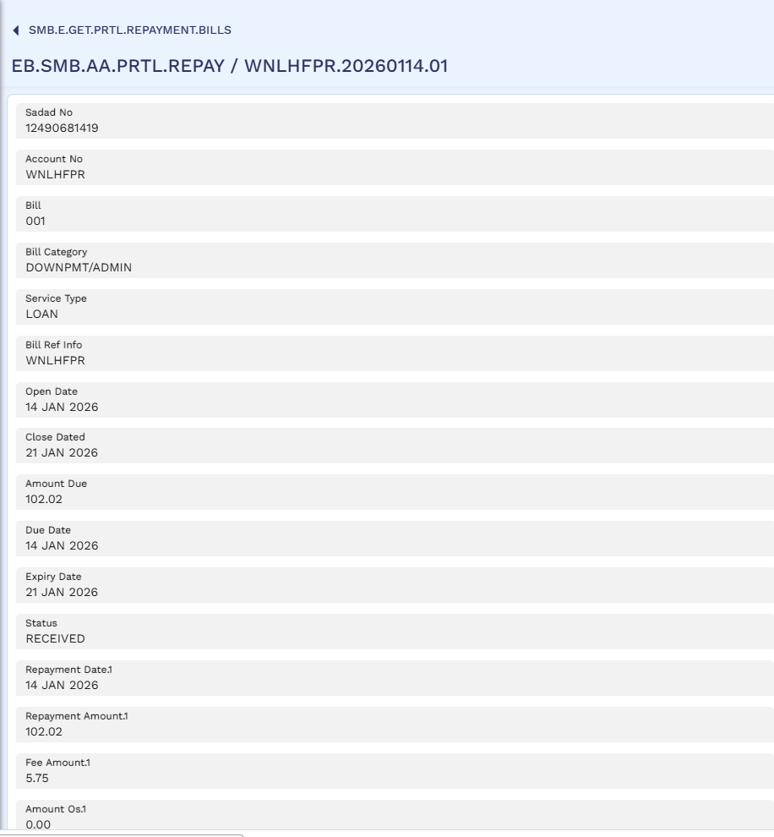

STP status enquiry - Bill Payment Confirmation
Below screenshot shows bill payment confirmation as successful.
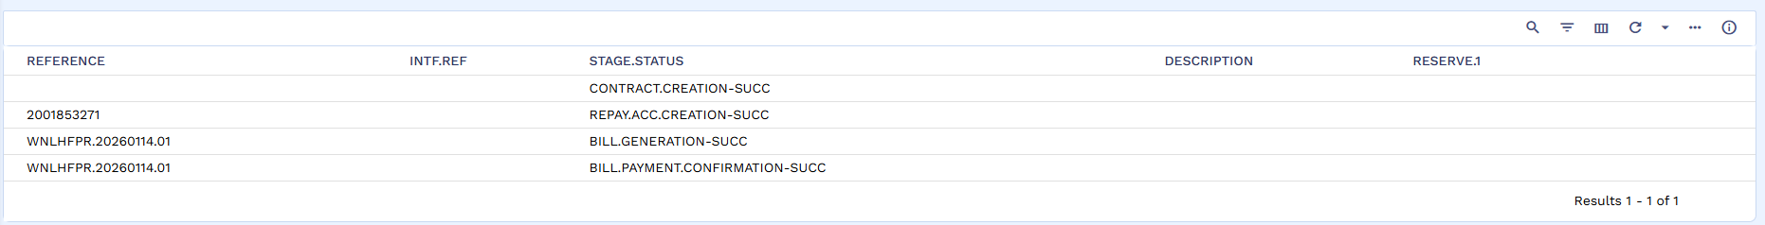
Admin Fees stage is marked as Paid.
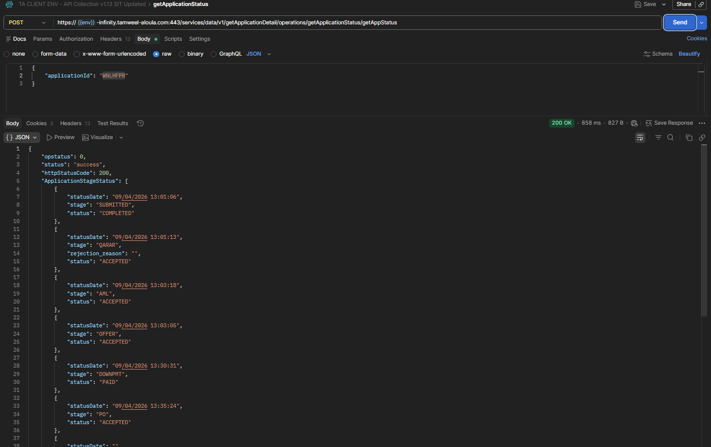

Credit Admin Stage
Admin Fees is marked as Paid and application is visible in Credit Admin’s queue to claim.
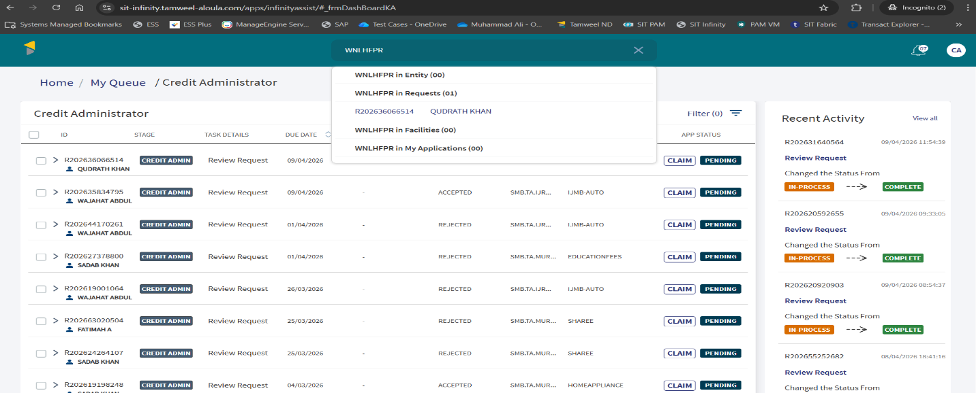

Application is claimed by Credit Admin and is visible in Credit Admin’s My Tasks Tab.
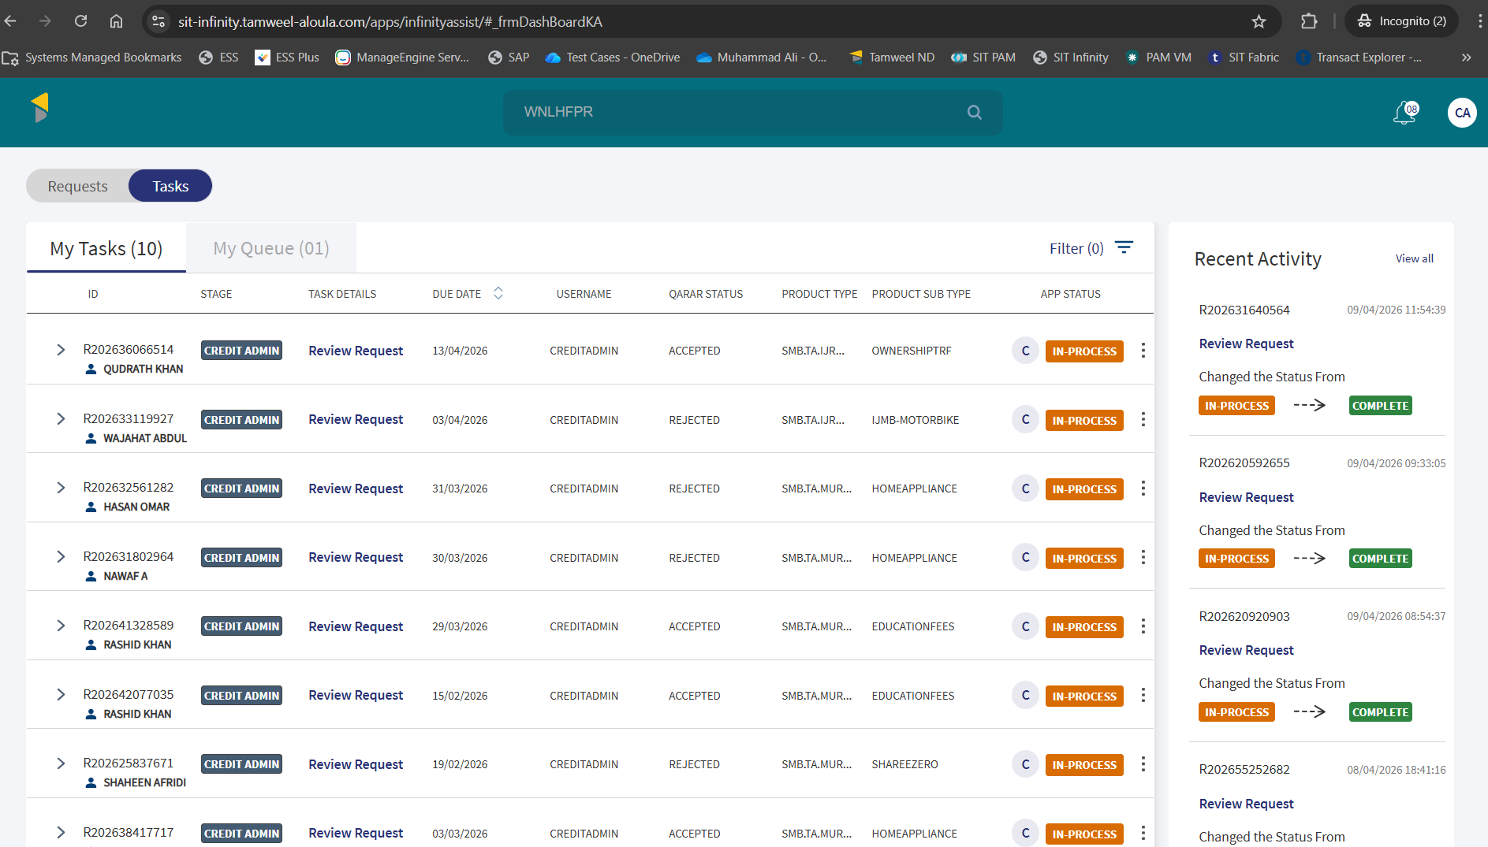

PO and Vendor Details of Application
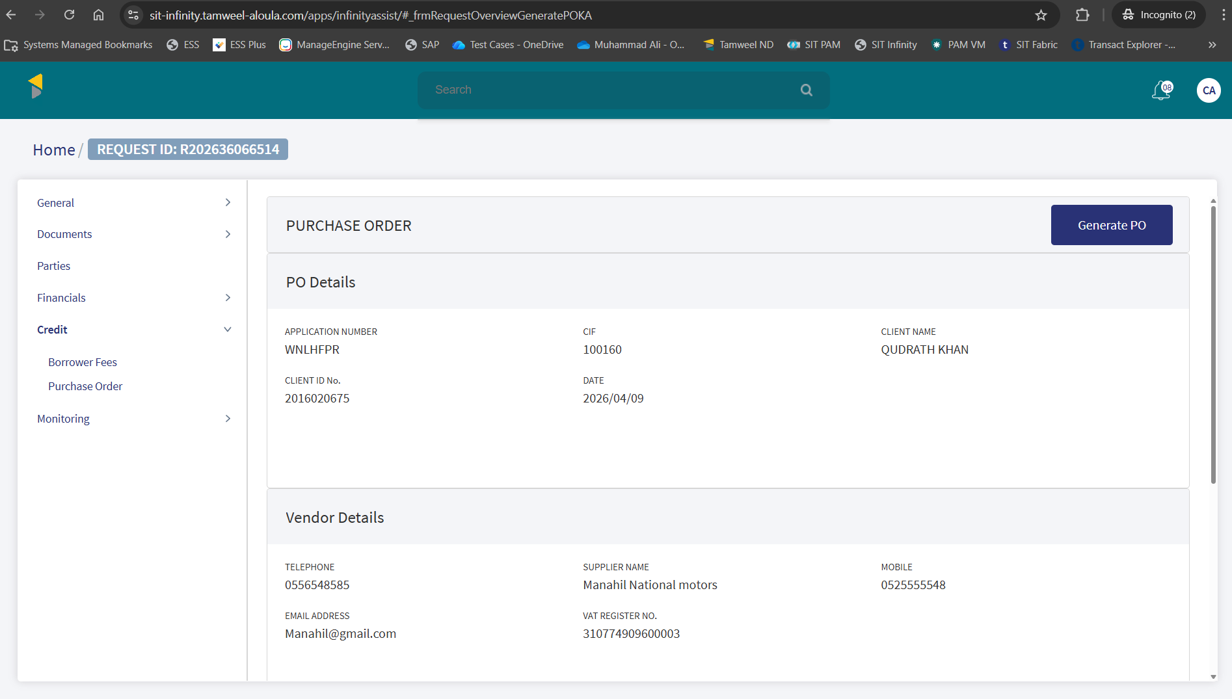

Financial Information of Application
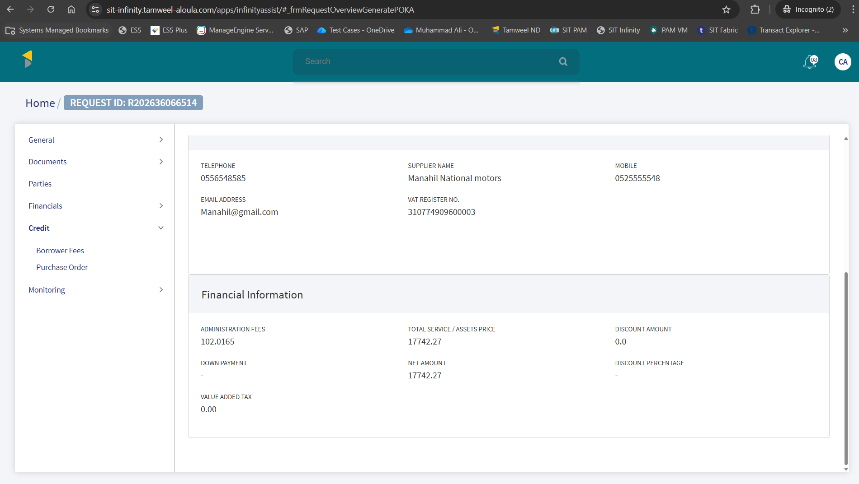

Purchase Order

PO Generation
Below screenshot shows that PO is generated.
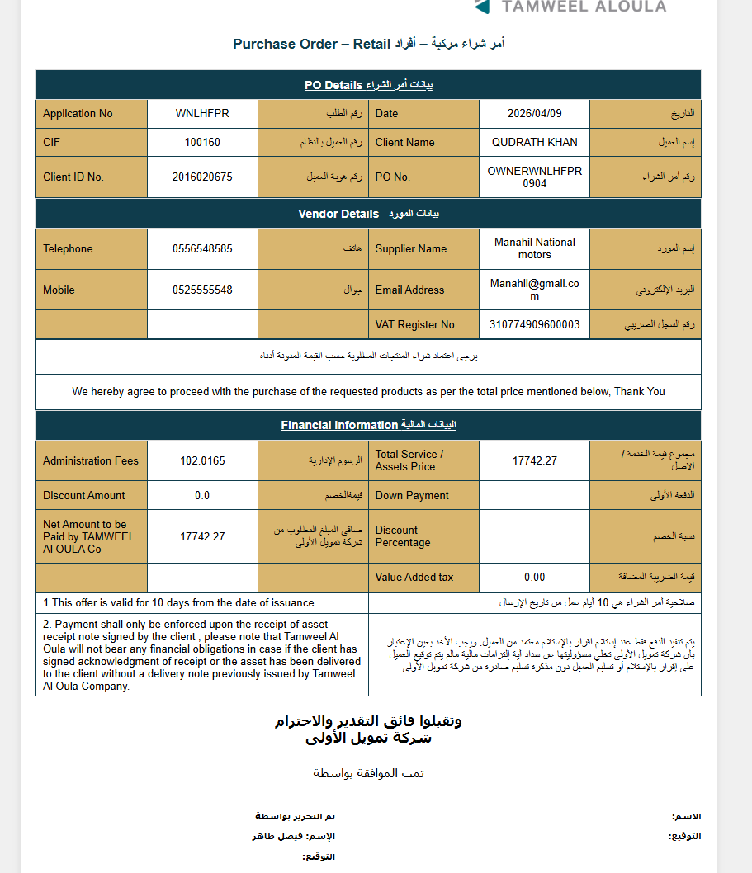

Successful Correspondence
Email is sent successfully for PO.
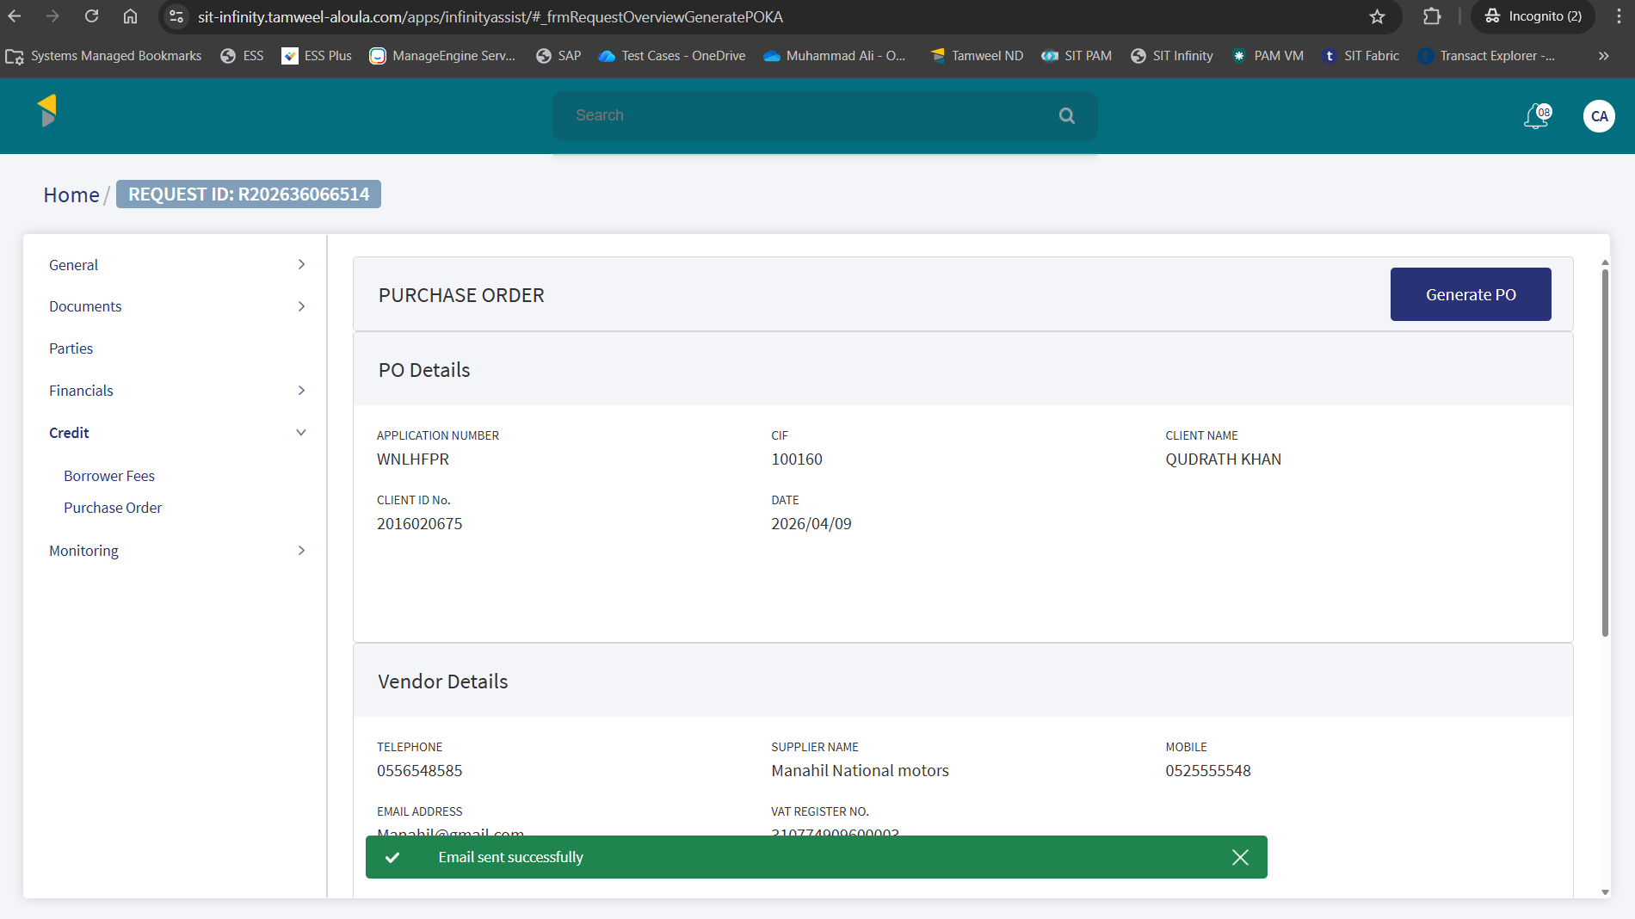
Application is approved from Credit Admin
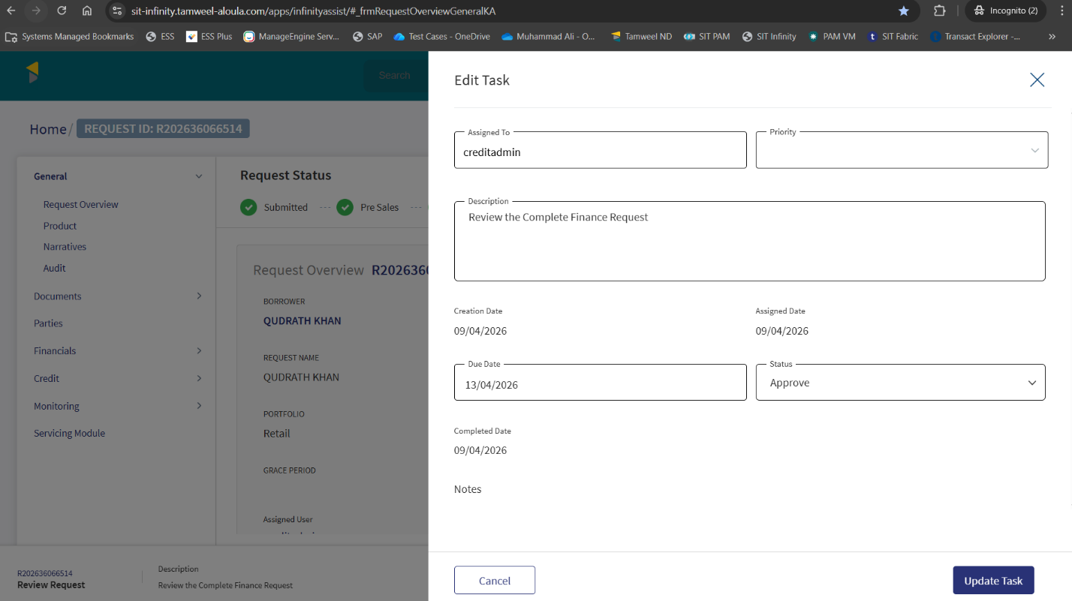

Updated PO
PO stage is updated to accepted.

Contract Status
Contract stage is updated as Generated.
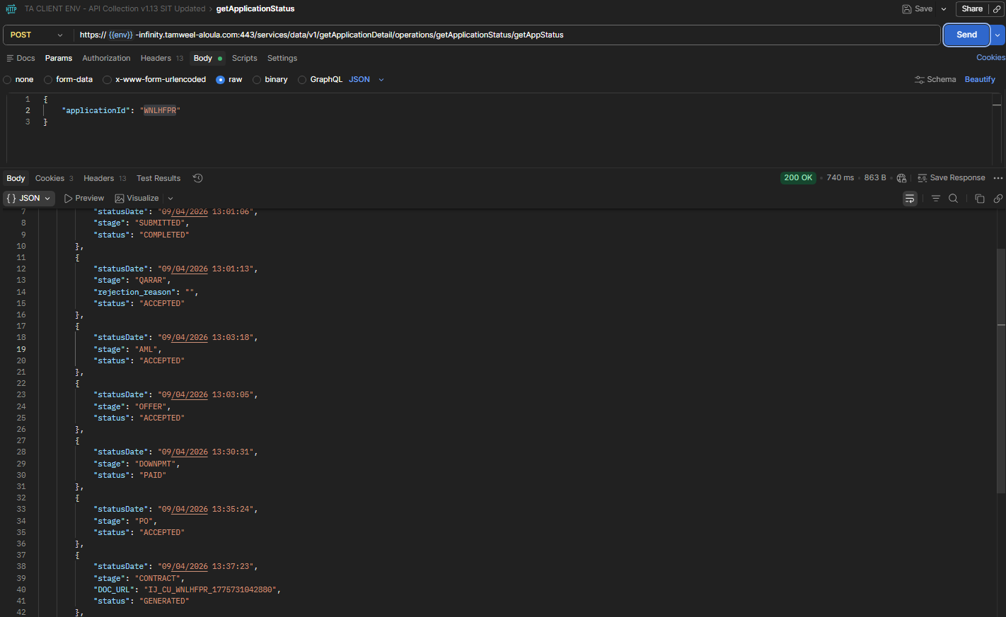

Contract Acceptance
Contract is accepted using UpdateStage Status API.
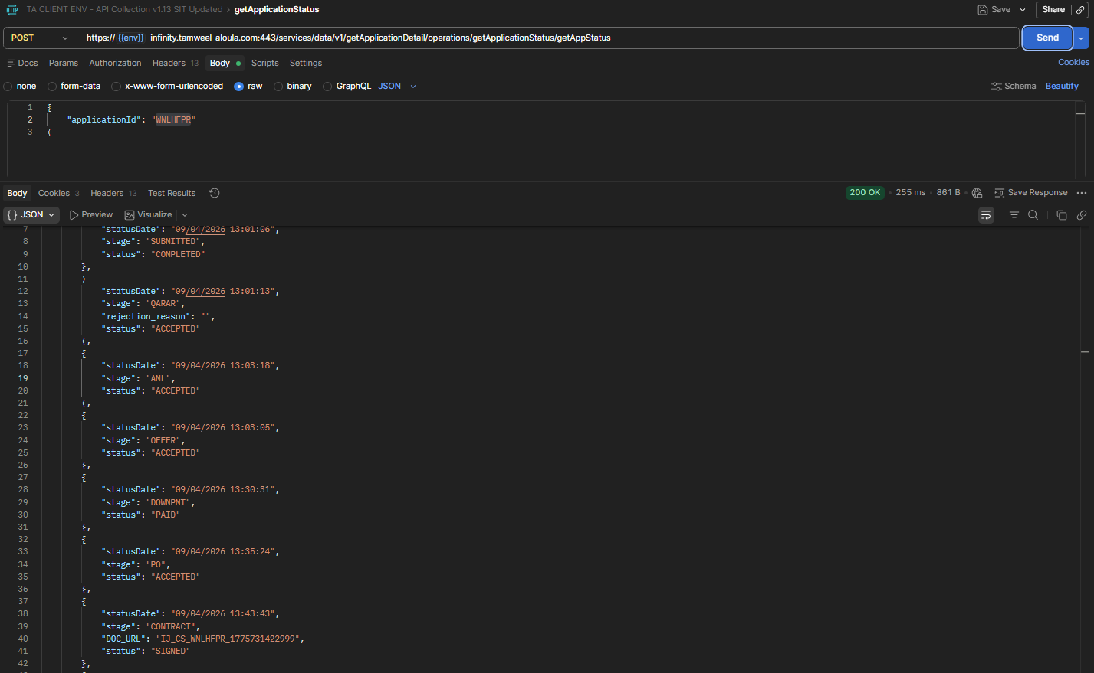
Contract status is marked as Signed.
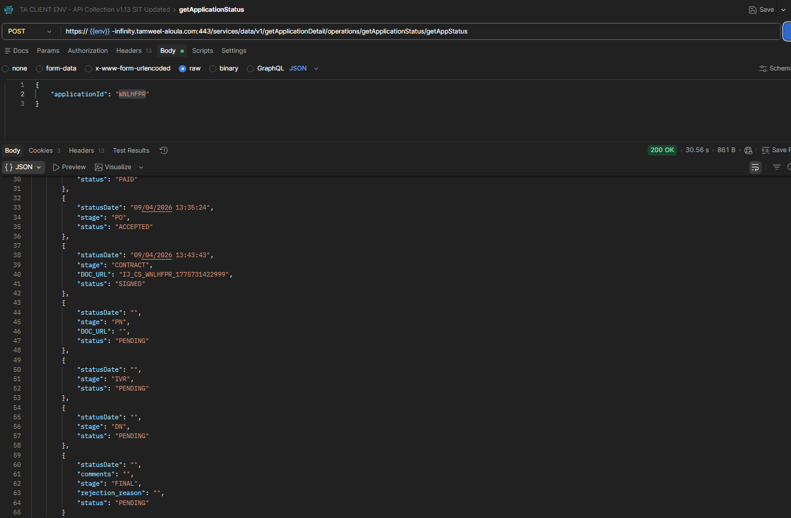
STP Status enquiry
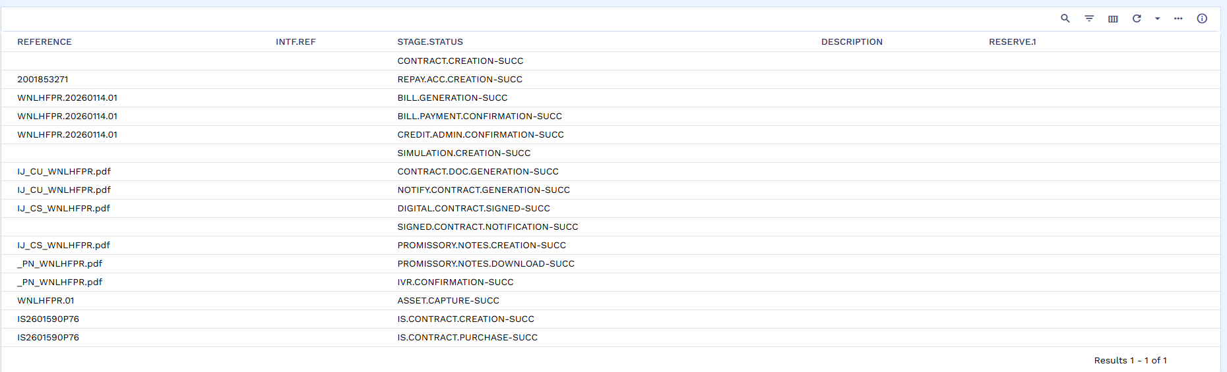

Asset Capture Amend
Click on asset capture amend.
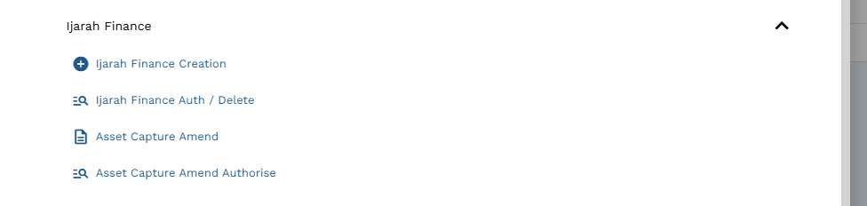

Input App ID and click edit.
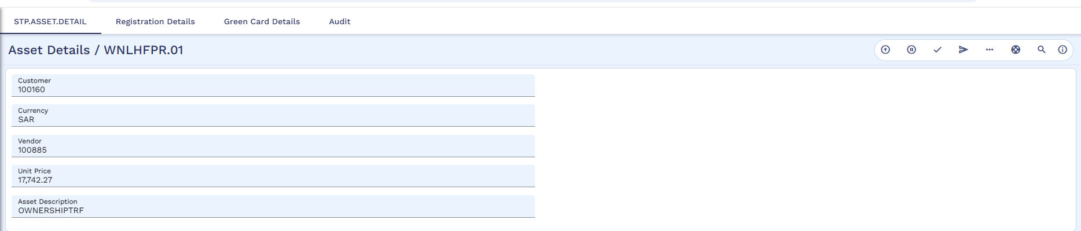
Click on Registration Details and input Registration Number, Registered At, Registration Expired on, and Istemara number. However, the Registration details will remain same as of old loan.
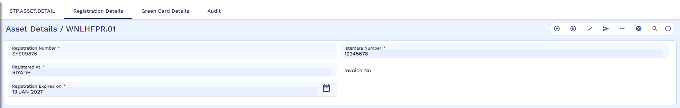

Commit the deal.
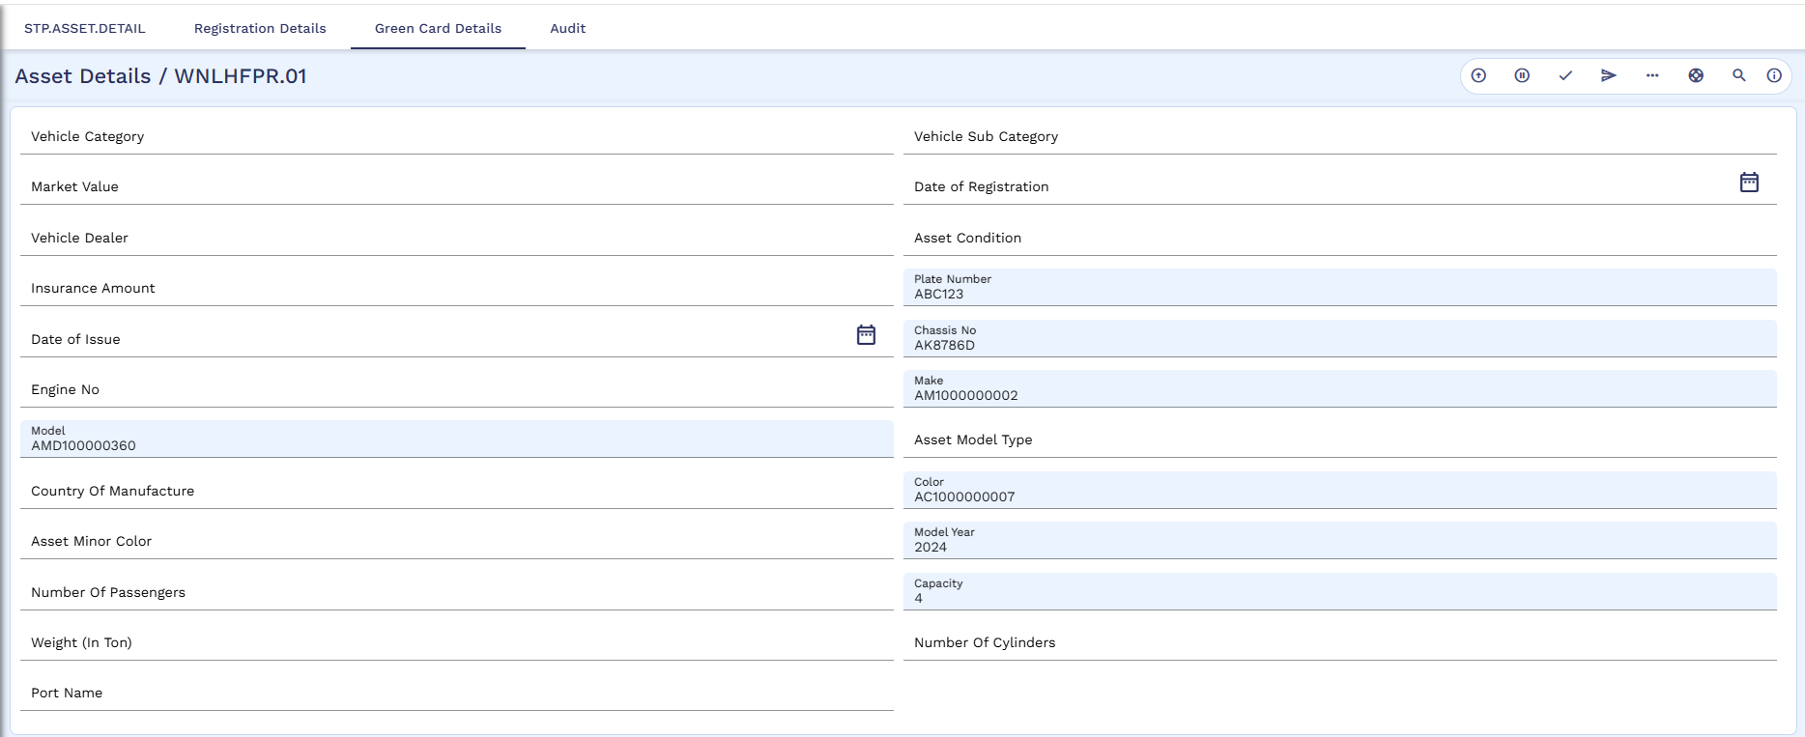
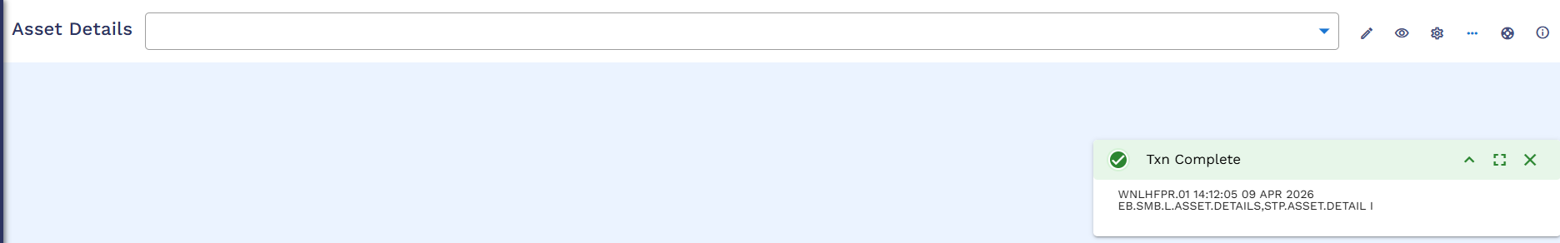

Authorization of Asset Capture Amend
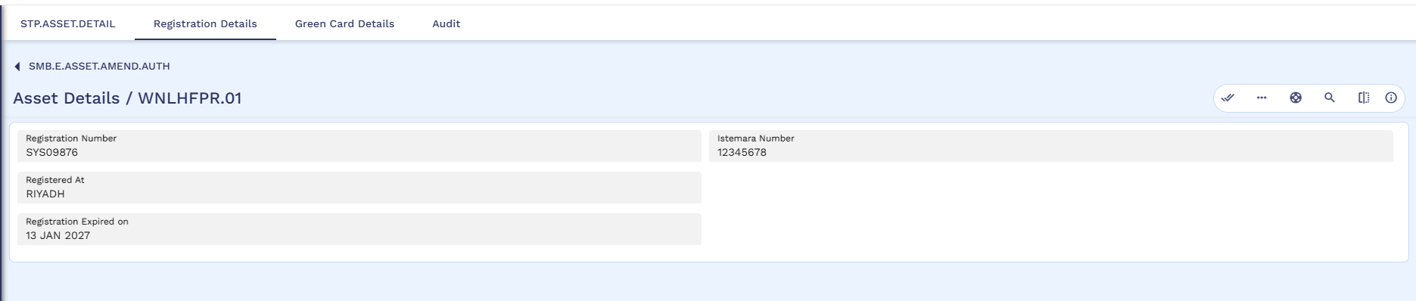
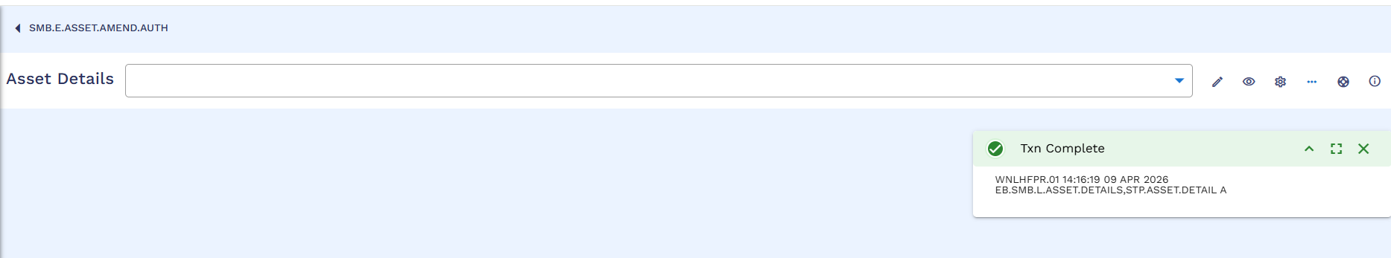

STP Status Enquiry – Complete
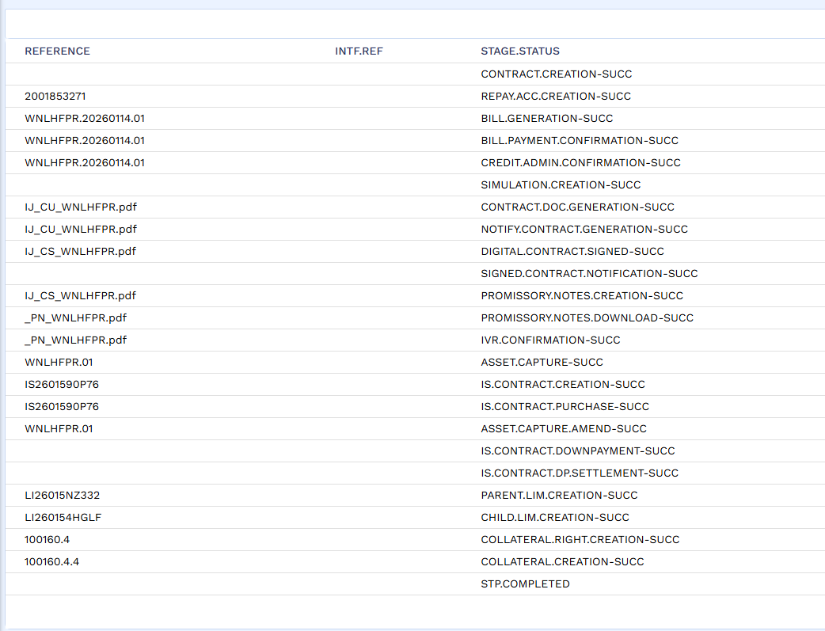

STP Accounting Entries
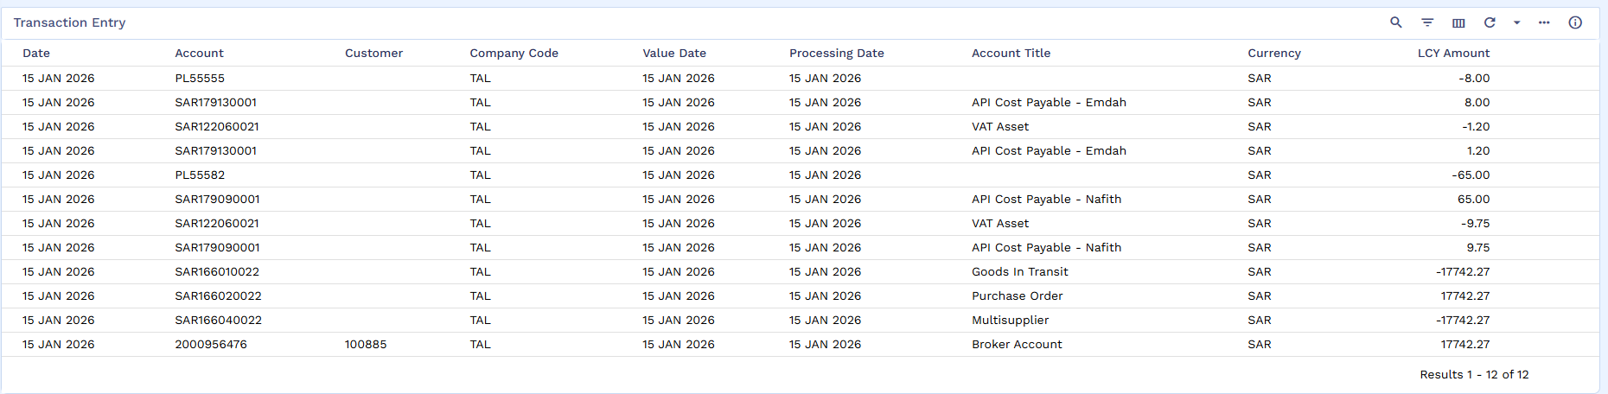

Restructured Arrangement Creation
Click on Ijarah Finance Creation.
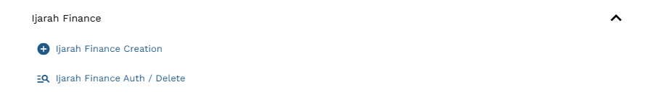

The user will manually create the Finance Arrangement with minimal inputs as some details will be auto fetch from IS Contract and SMB.DEAL. DETAILS.
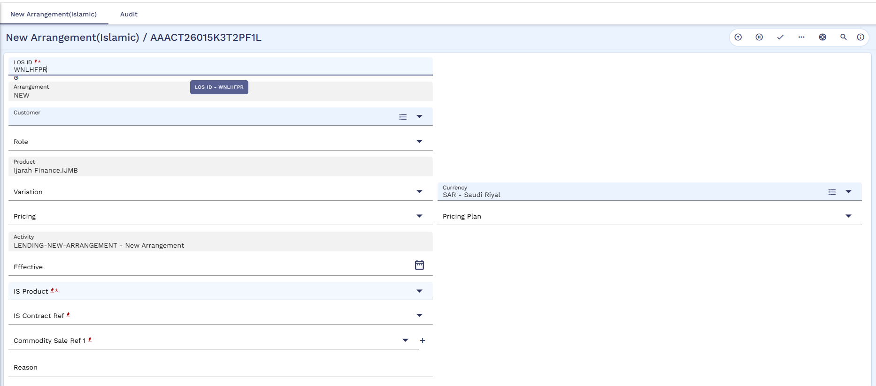
The record will auto populate.
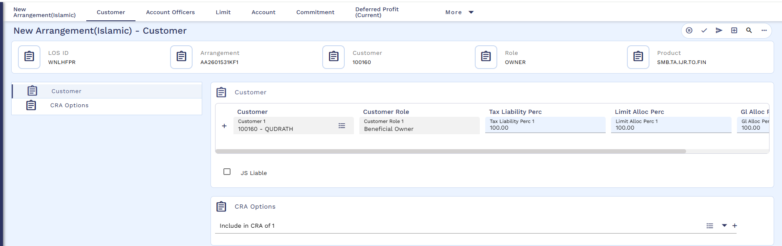
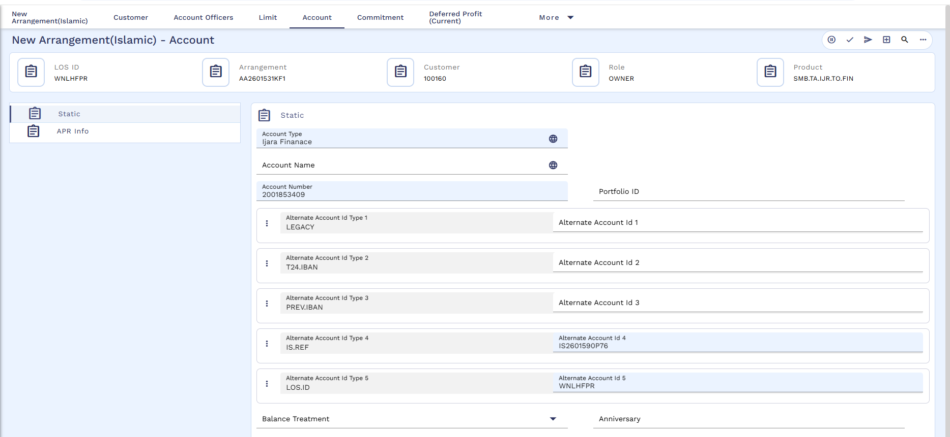
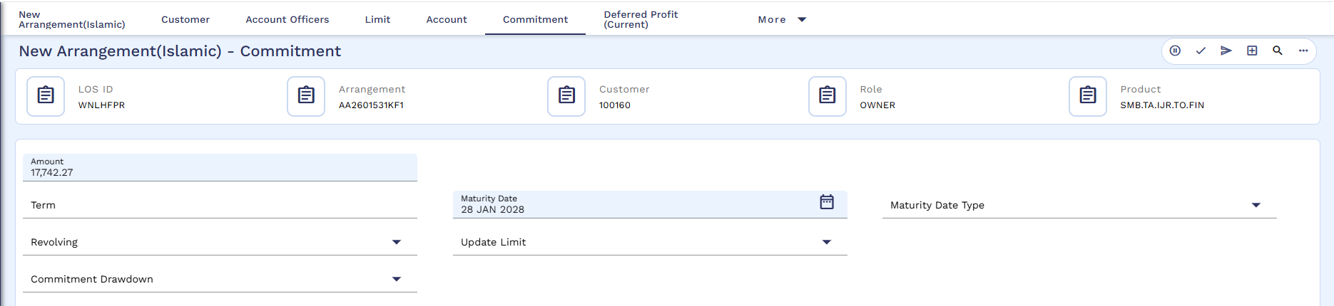
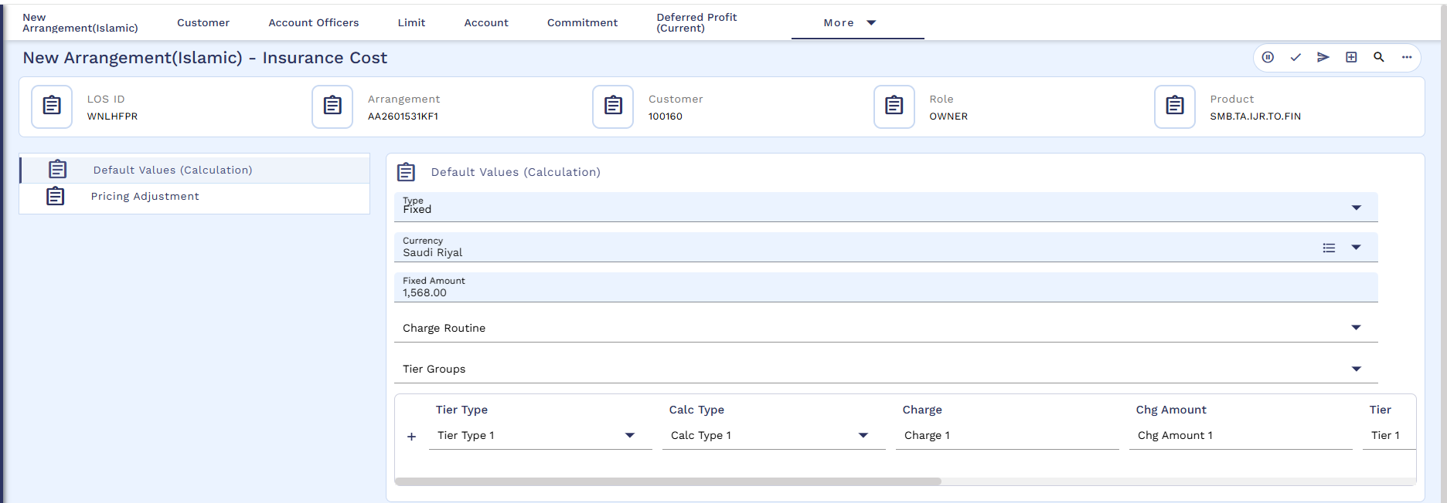
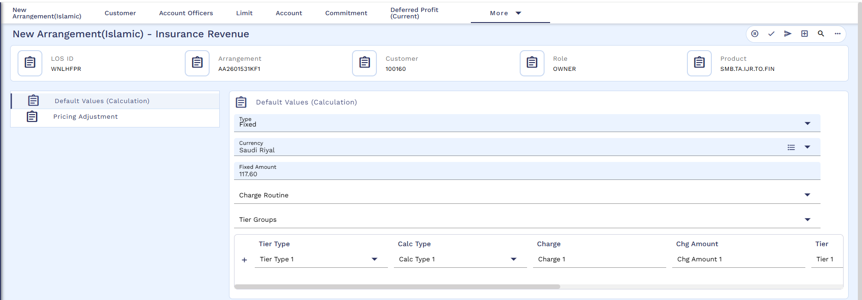
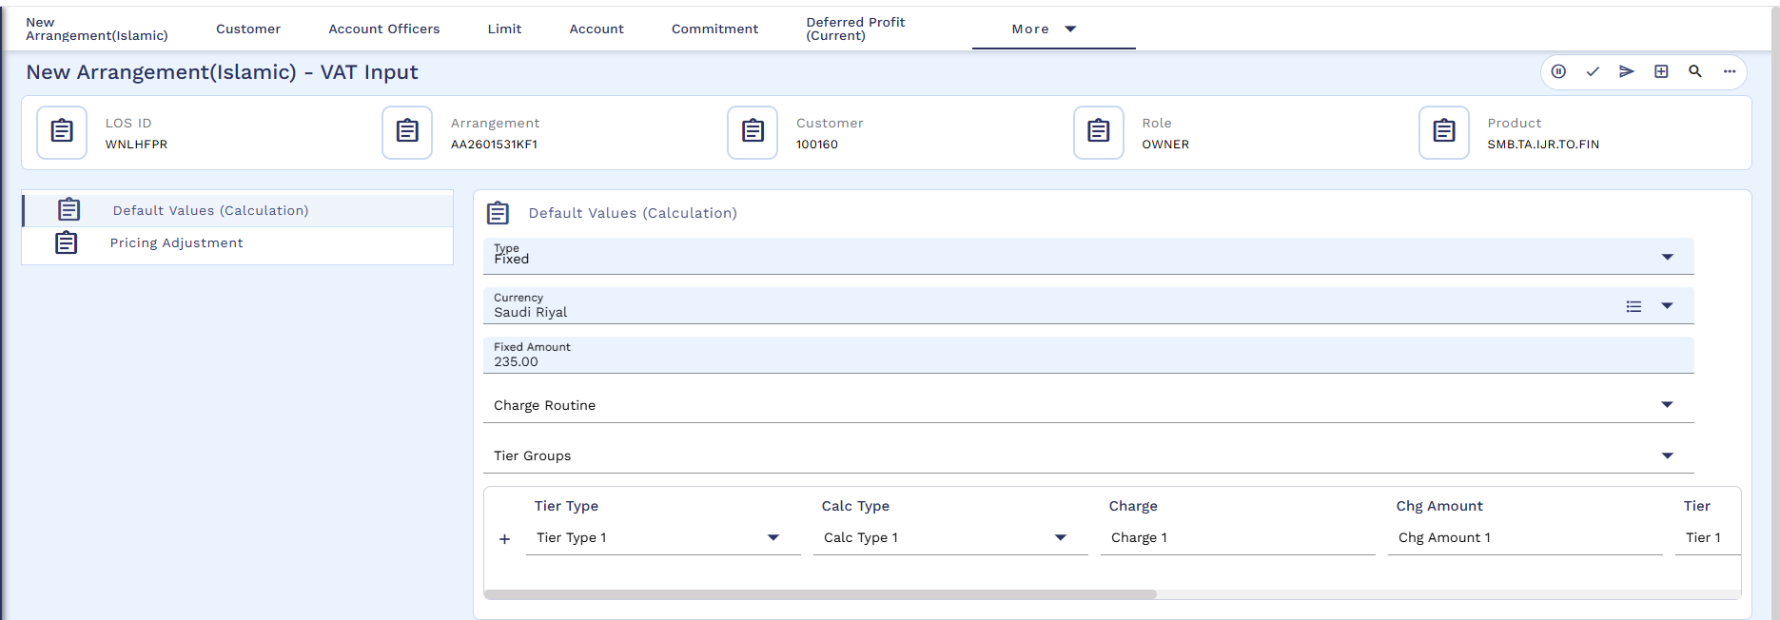
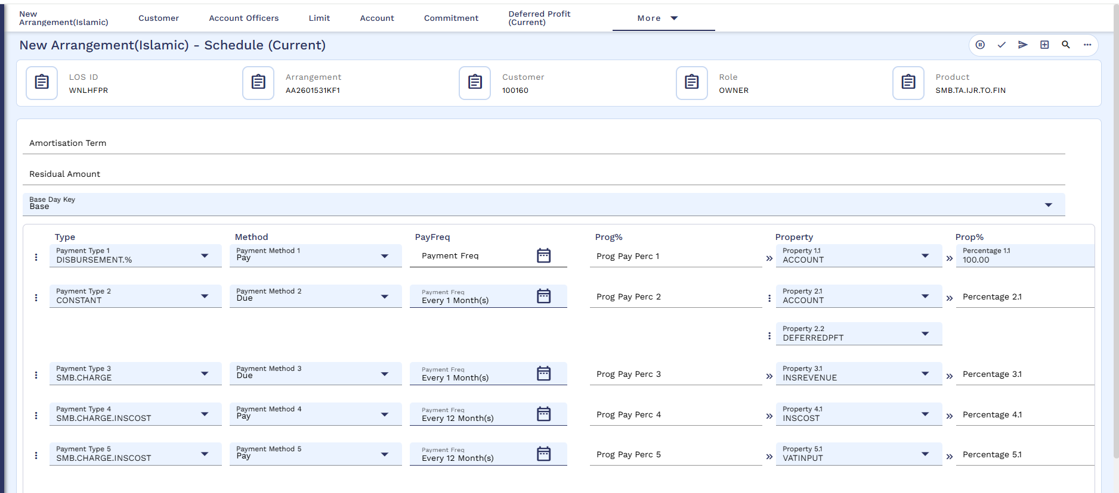

Validate and commit the deal.
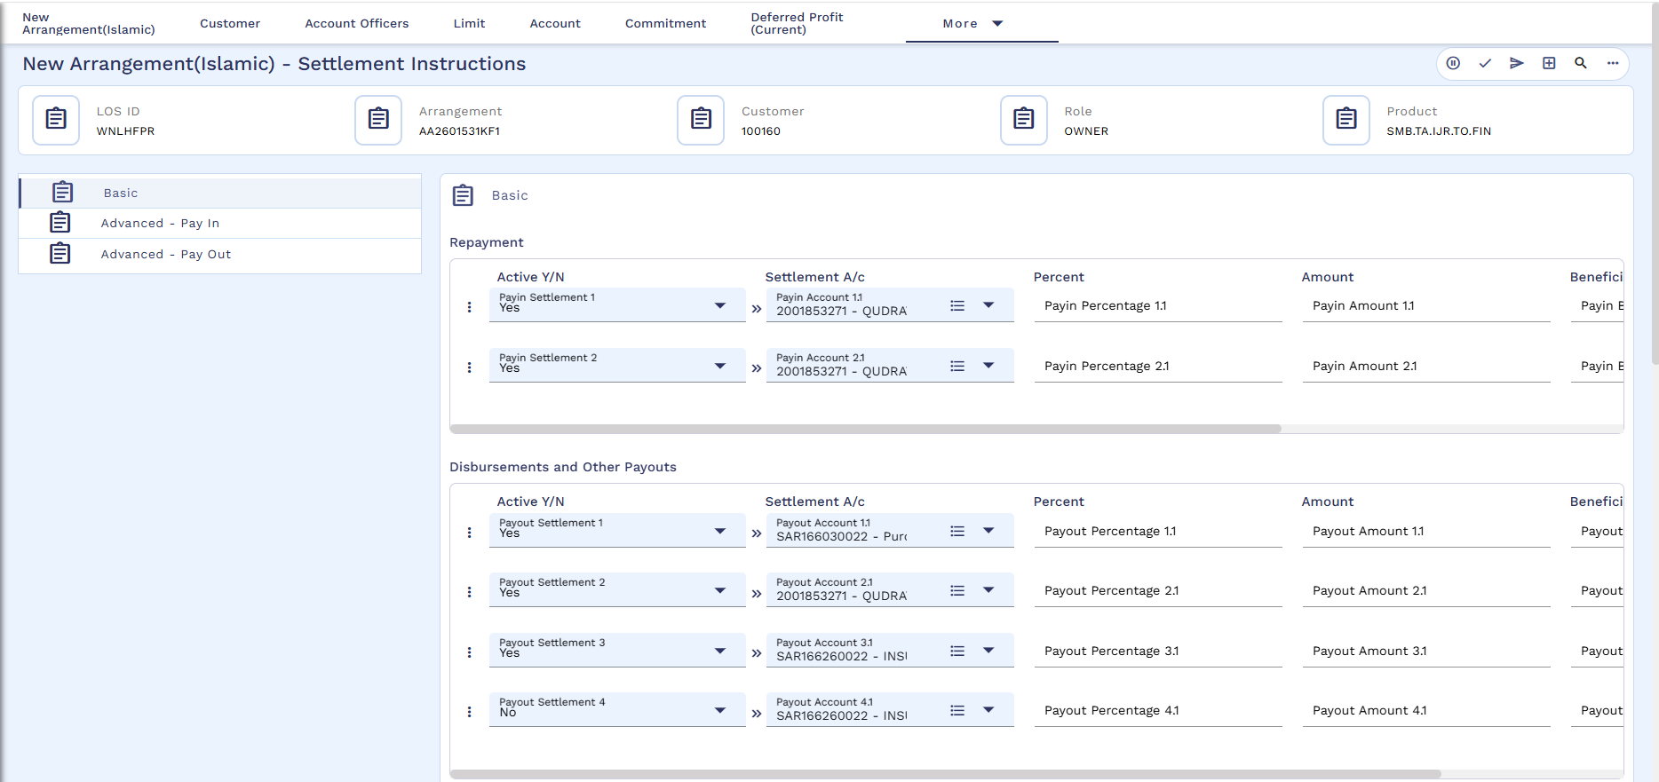
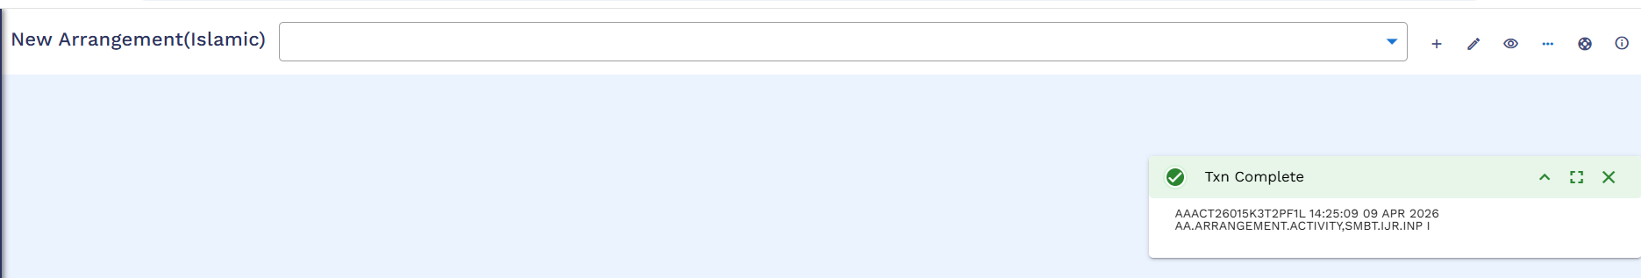

Authorization of Restructured Arrangement
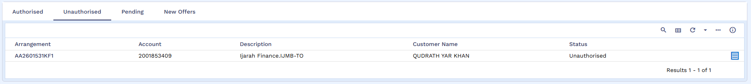
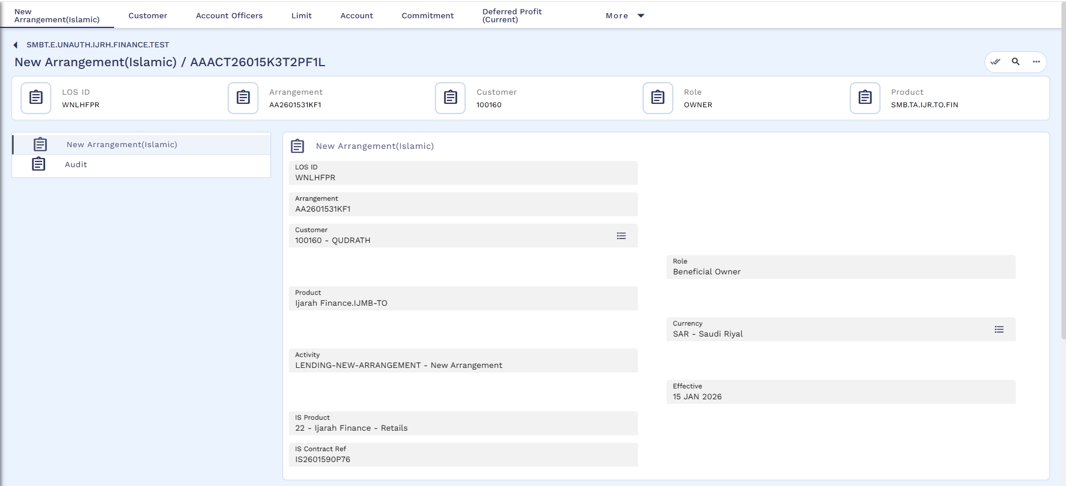
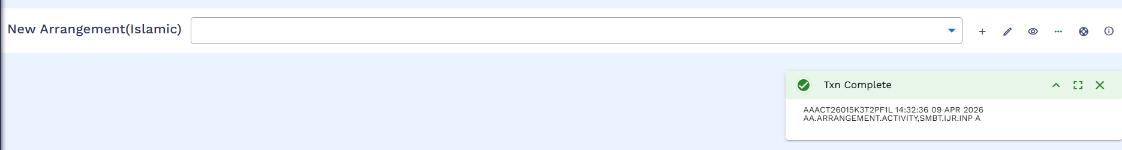

Arrangement 360 View
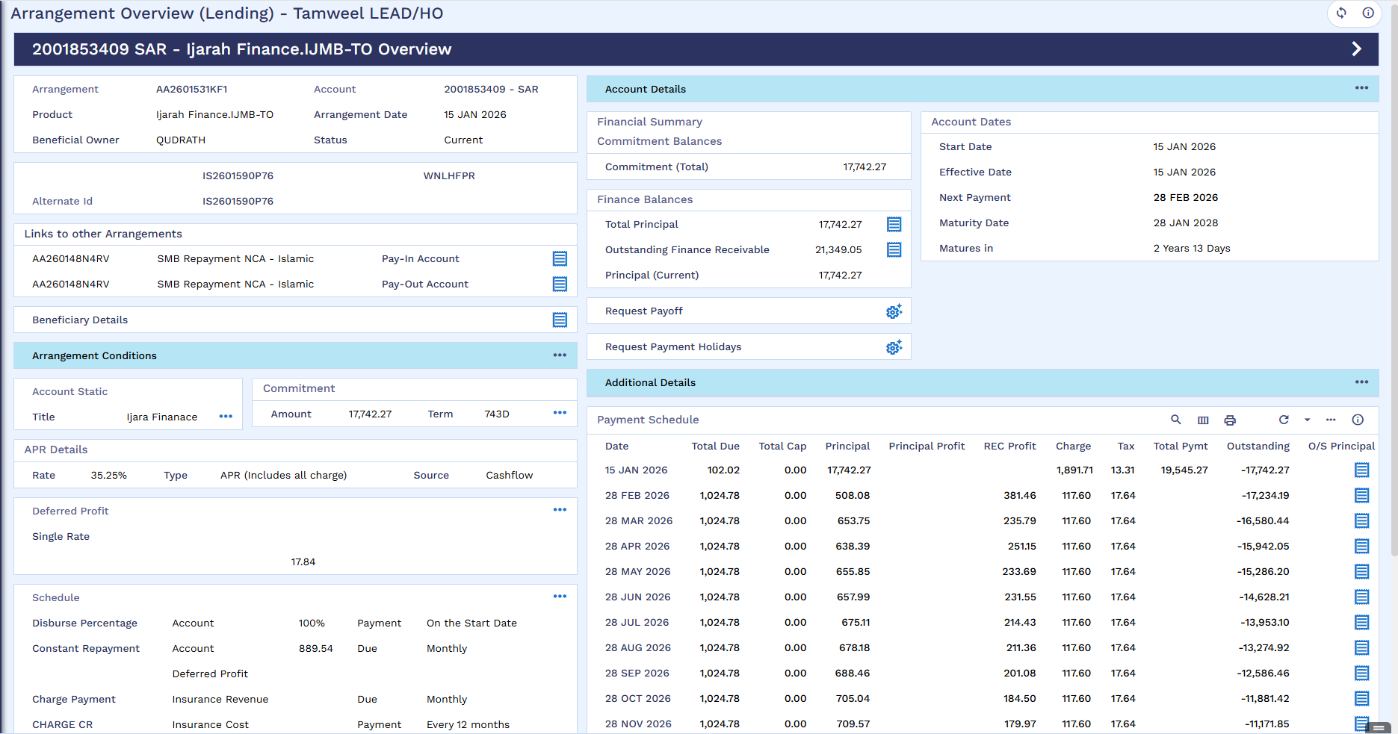

List of Transaction Entries
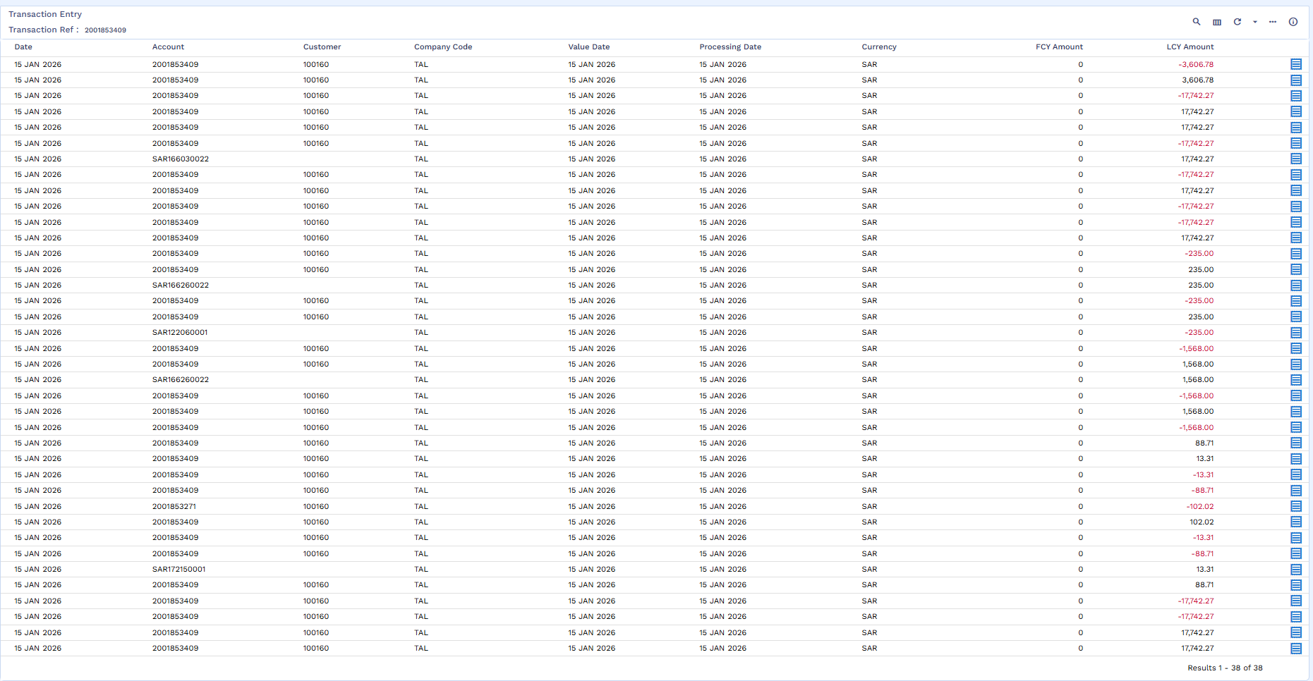

Multi-supplier Account
Below screenshot shows that the amount has been credited in Multi-supplier Account.
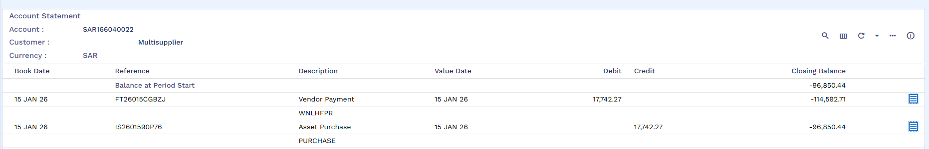

Fund Transfer
Once the new loan arrangement is booked old loan contract will be adjusted and closed from the proceed of new loan arrangement by user manually.

FT Creation
Now FT will be performed, where funds from the Multi-supplier Account will be credited to the old arrangement’s repayment account. Input the details and commit.
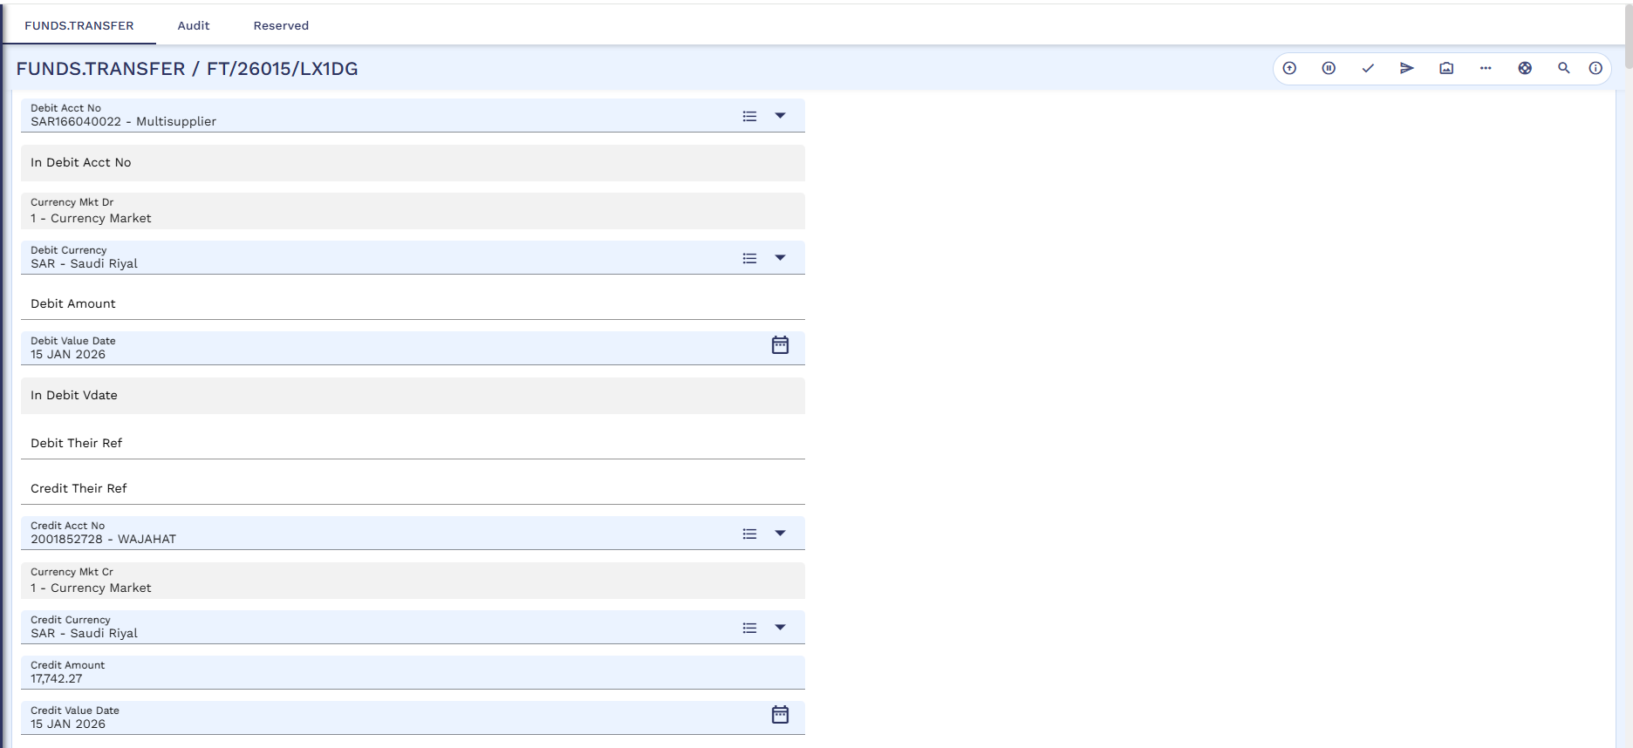
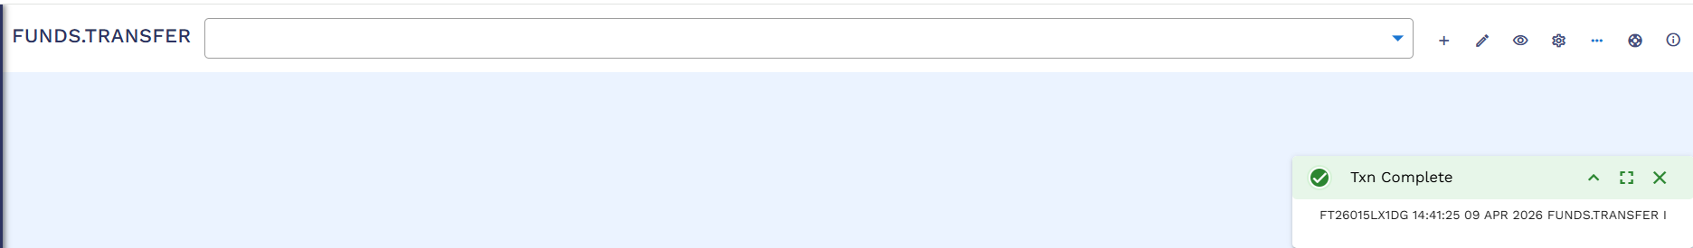

FT Authorization
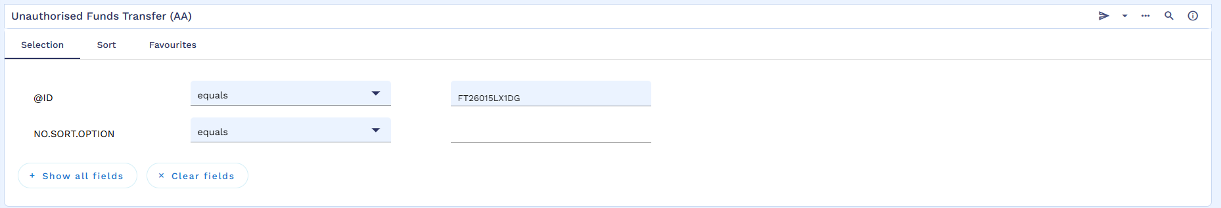
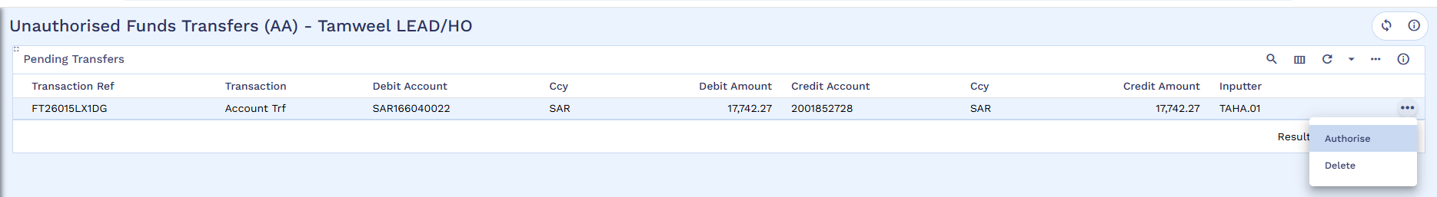
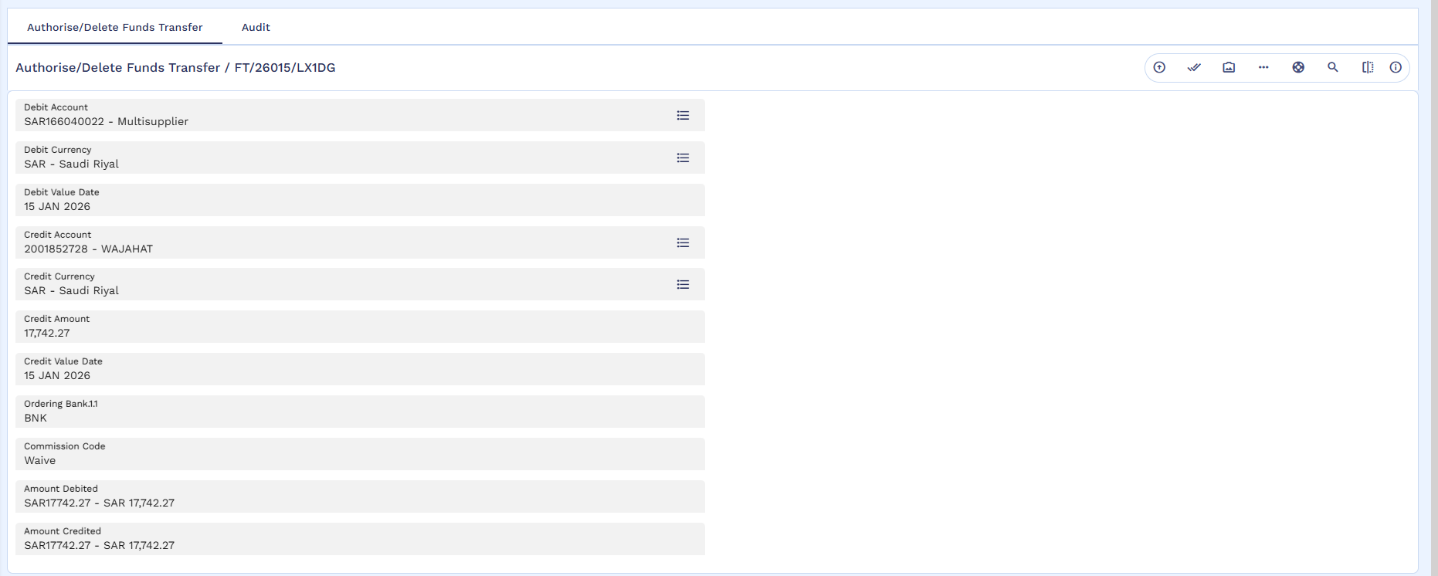

FT Credited in Previous Loan Repayment Account
Below screenshot shows the previous arrangement’s repayment account after the FT execution. The funds are credited into the repayment account.
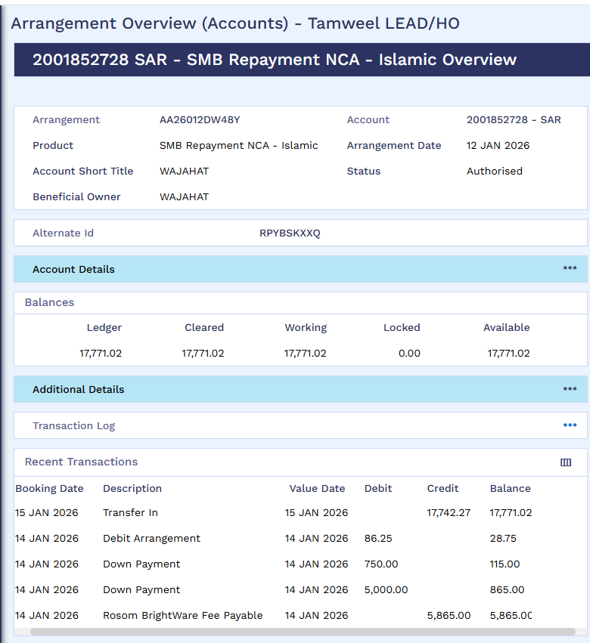

Payoff

Previous Loan Payoff
Menu -> Islamic Operations -> IS Credit Management -> Finance Transactions -> Arrangement Activities (FT) -> AA Pay-off.
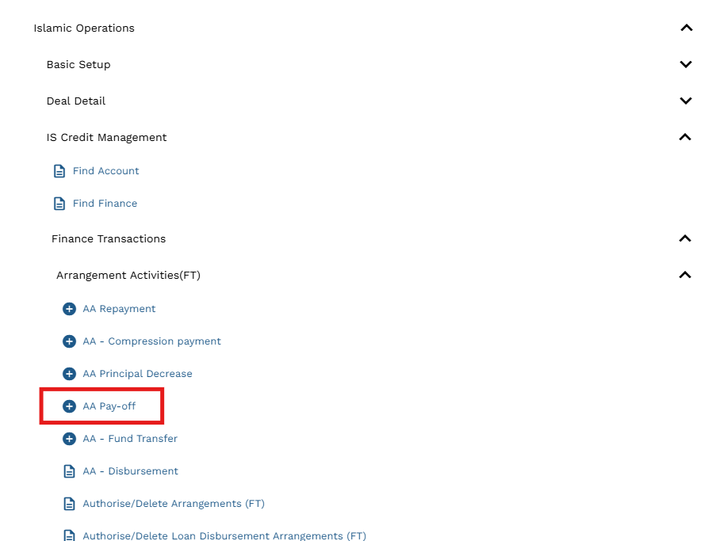
Input the credit account, debit account, credit currency and credit amount. Then validate and commit.
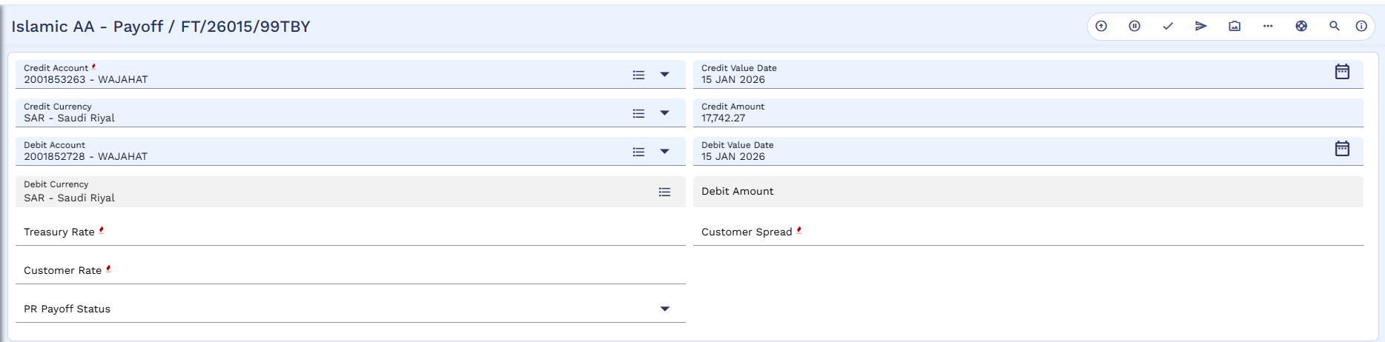
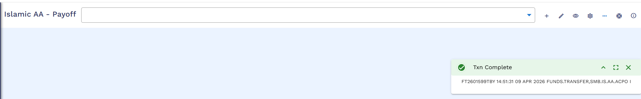

Payoff Authorization
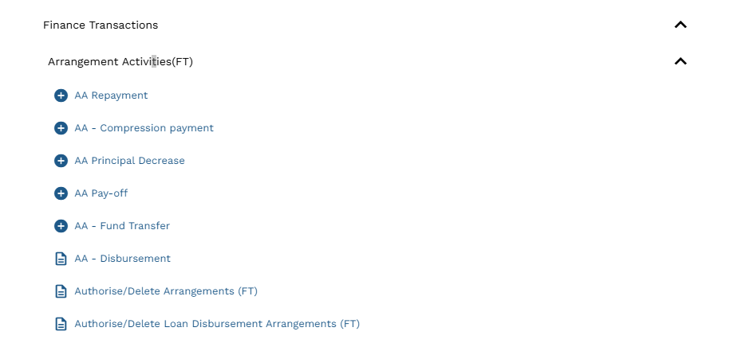
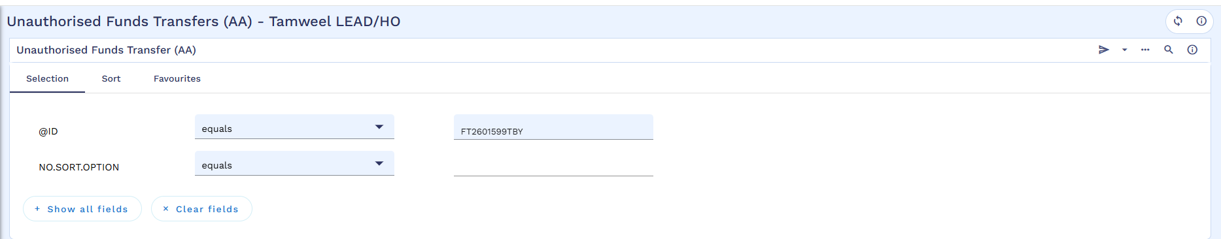
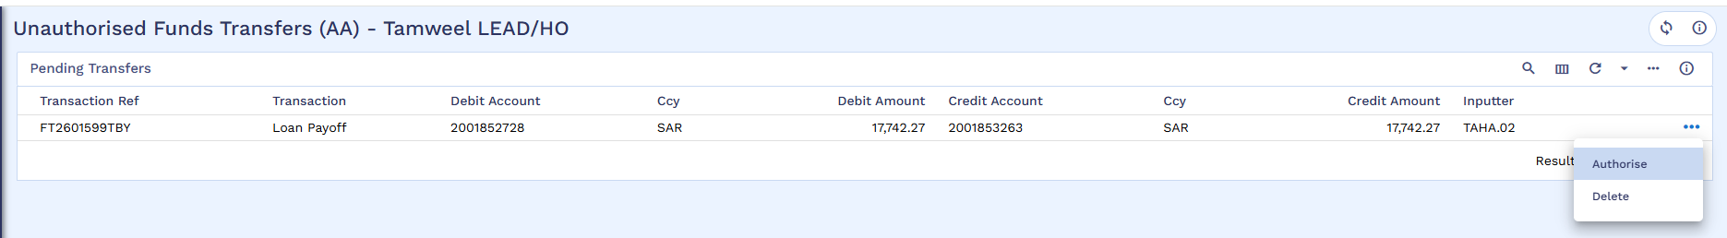
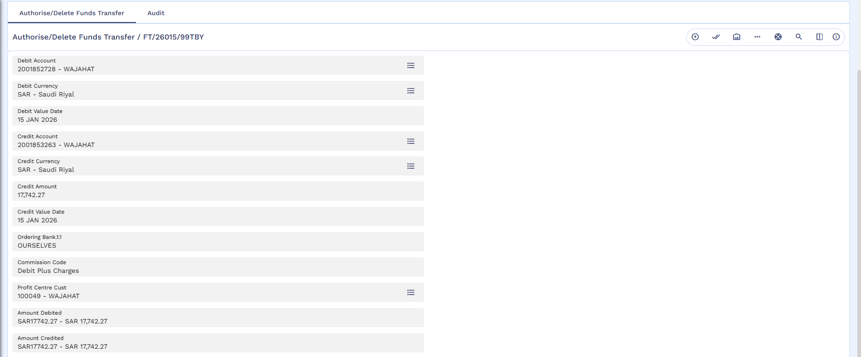
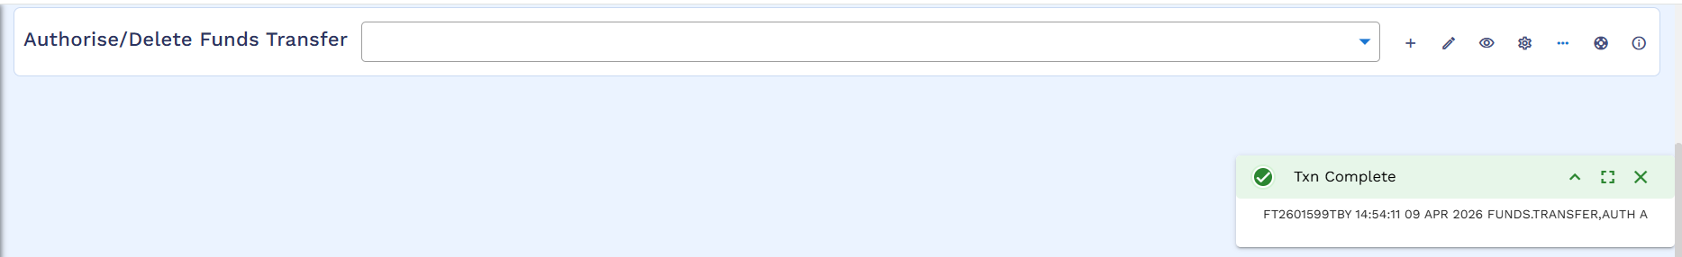

Arrangement after Payoff
Below Arrangement is the old arrangement which is settled through new restructured arrangement.
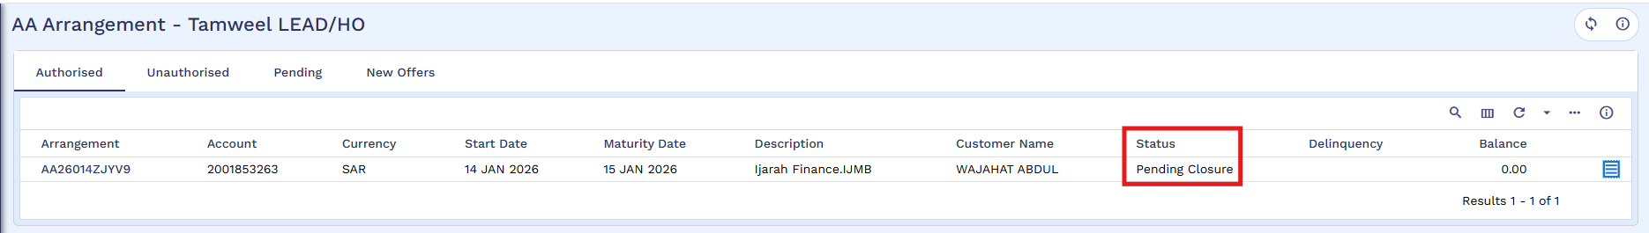
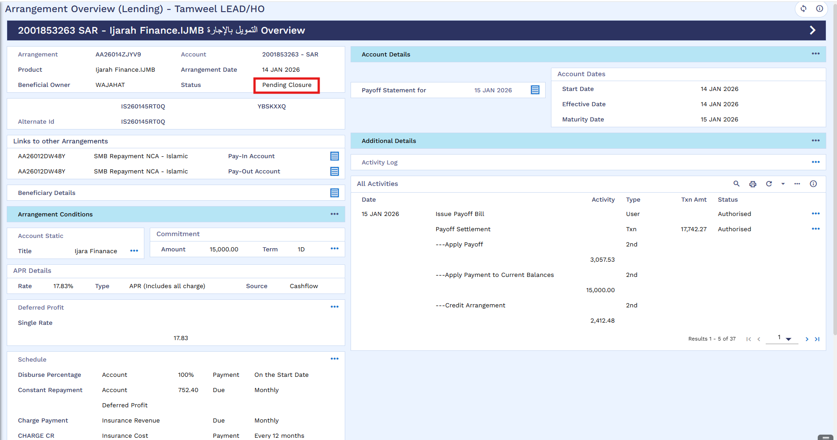

Schedule
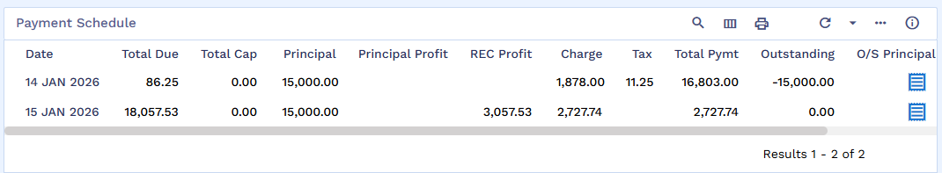

Transaction Entry After Payoff

